**Tableau Tutorial for Beginners: Learn in 3 Days**

### Training Summary

Tableau is a pioneering data visualization tool. Tableau connects to almost any data source like Datawarehouse, Excel, Database, etc. It provides real-time data insights in a matter of minutes. In this tutorial, you will learn everything about Tableau.

### What should I know?

This free Tableau tutorial is designed for beginners.

# What is Tableau? Uses and Applications

## What is Tableau?

Tableau is a powerful and fastest growing data visualization tool used in the Business Intelligence Industry. It helps in simplifying raw data into the very easily understandable format.

Data analysis is very fast with Tableau and the visualizations created are in the form of dashboards and worksheets. The data that is created using Tableau can be understood by professional at any level in an organization. It even allows a non-technical user to create a customized dashboard.

The best feature Tableau are

* Data Blending
* Real time analysis
* Collaboration of data
* he great thing about Tableau software is that it doesn't require any technical or any kind of programming skills to operate. The tool has garnered interest among the people from all sectors such as business, researchers, different industries, etc.
* In this tutorial, you will learn-
* [What is Tableau?](https://www.guru99.com/what-is-tableau.html#1)
* [Tableau product suite](https://www.guru99.com/what-is-tableau.html#2)
* [Tableau Desktop](https://www.guru99.com/what-is-tableau.html#3)
* [Tableau Public](https://www.guru99.com/what-is-tableau.html#4)
* [Tableau Server](https://www.guru99.com/what-is-tableau.html#5)
* [Tableau Online](https://www.guru99.com/what-is-tableau.html#6)
* [Tableau Reader](https://www.guru99.com/what-is-tableau.html#7)
* [How does Tableau work?](https://www.guru99.com/what-is-tableau.html#8)
* [Excel Vs. Tableau](https://www.guru99.com/what-is-tableau.html#9)

## Tableau Product Suite

The Tableau Product Suite consists of

* Tableau Desktop
* Tableau Public
* Tableau Online
* Tableau Server
* Tableau Reader

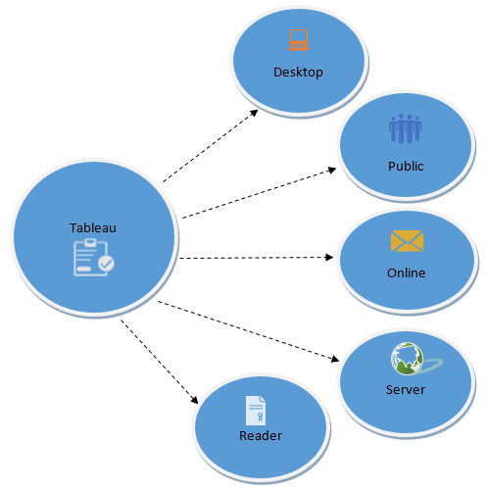

For clear understanding, data analytics in tableau can be classified into two section

1. **Developer Tools:** The Tableau tools that are used for development such as the creation of dashboards, charts, report generation, visualization fall into this category. The Tableau products, under this category, are the Tableau Desktop and the Tableau Public.
2. **Sharing Tools**: As the name suggests, the purpose of the tool is sharing the visualizations, reports, dashboards that were created using the developer tools. Products that fall into this category are Tableau Online, Server, and Reader.

Let's study all the products one by one.

### Tableau Desktop

Tableau Desktop has a rich feature set and allows you to code and customize reports. Right from creating the charts, reports, to blending them all together to form a dashboard, all the necessary work is created in Tableau Desktop.

For live data analysis, Tableau Desktop provides connectivity to Data Warehouse, as well as other various types of files. The workbooks and the dashboards created here can be either shared locally or publicly.

Based on the connectivity to the data sources and publishing option, Tableau Desktop is classified into

* **Tableau Desktop Personal:**The development features are similar to Tableau Desktop. Personal version keeps the workbook private, and the access is limited. The workbooks cannot be published online. Therefore, it should be distributed either Offline or in Tableau Public.
* **Tableau Desktop Professional:**It is pretty much similar to Tableau Desktop. The difference is that the work created in the Tableau Desktop can be published online or in Tableau Server. Also, in Professional version, there is full access to all sorts of the datatype. It is best suitable for those who wish to publish their work in Tableau Server.

### Tableau Public

It is Tableau version specially build for the cost-effective users. By the word "Public," it means that the workbooks created cannot be saved locally, in turn, it should be saved to the Tableau's public cloud which can be viewed and accessed by anyone.

There is no privacy to the files saved to the cloud since anyone can download and access the same. This version is the best for the individuals who want to learn Tableau and for the ones who want to share their data with the general public.

### Tableau Server

The software is specifically used to share the workbooks, visualizations that are created in the Tableau Desktop application across the organization. To share dashboards in the Tableau Server, you must first publish your work in the Tableau Desktop. Once the work has been uploaded to the server, it will be accessible only to the licensed users.

However, It's not necessary that the licensed users need to have the Tableau Server installed on their machine. They just require the login credentials with which they can check reports via a web browser. The security is high in Tableau server, and it is much suited for quick and effective sharing of data in an organization.

The admin of the organization will always have full control over the server. The hardware and the software are maintained by the organization.

### Tableau Online

As the name suggests, it is an online sharing tool of Tableau. Its functionalities are similar to Tableau Server, but the data is stored on servers hosted in the cloud which are maintained by the Tableau group.

There is no storage limit on the data that can be published in the Tableau Online. Tableau Online creates a direct link to over 40 data sources that are hosted in the cloud such as the MySQL, Hive, Amazon Aurora, Spark SQL and many more.

To publish, both Tableau Online and Server require the workbooks created by Tableau Desktop. Data that is streamed from the web applications say Google Analytics, Salesforce.com are also supported by Tableau Server and Tableau Online.

### Tableau Reader

Tableau Reader is a free tool which allows you to view the workbooks and visualizations created using Tableau Desktop or Tableau Public. The data can be filtered but editing and modifications are restricted. The security level is zero in Tableau Reader as anyone who gets the workbook can view it using Tableau Reader.

If you want to share the dashboards that you have created, the receiver should have Tableau Reader to view the document.

## How does Tableau work?

Tableau connects and extracts the data stored in various places. It can pull data from any platform imaginable. A simple database such as an excel, pdf, to a complex database like Oracle, a database in the cloud such as Amazon webs services, Microsoft Azure SQL database, Google Cloud SQL and various other data sources can be extracted by Tableau.

When Tableau is launched, ready data connectors are available which allows you to connect to any database. Depending on the version of Tableau that you have purchased the number of data connectors supported by Tableau will vary.

The pulled data can be either connected live or extracted to the Tableau's data engine, Tableau Desktop. This is where the Data analyst, data engineer work with the data that was pulled up and develop visualizations. The created dashboards are shared with the users as a static file. The users who receive the dashboards views the file using Tableau Reader.

The data from the Tableau Desktop can be published to the Tableau server. This is an enterprise platform where collaboration, distribution, governance, security model, automation features are supported. With the Tableau server, the end users have a better experience in accessing the files from all locations be it a desktop, mobile or email.

## Excel Vs. Tableau

Both Excel and Tableau are data analysis tools, but each tool has its unique approach to data exploration. However, the analysis in Tableau is more potent than excel.

Excel works with rows and columns in spreadsheets whereas Tableau enables in exploring excel data using its drag and drop feature. Tableau formats the data in Graphs, pictures that are easily understandable.

| **Parameters** | **Excel** | **Tableau** |
| --- | --- | --- |
| Purpose | Spreadsheet application used for manipulating the data. | Perfect visualization tool used for analysis. |
| Usage | Most suitable for statistical analysis of structured data. | Most suitable for quick and easy representation of big data which helps in resolving the big data issues. |
| Performance | Moderate speed with no option to quicken. | Moderate speed with options to optimize and enhance the progress of an operation. |
| Security | The inbuilt security feature is weak when compared to Tableau. The security update needs to be installed on a regular basis. | Extensive options to secure data without scripting. Security features like row level security and permission are inbuilt. |
| User Interface | To utilize excel to full potential, macro and visual basic scripting knowledge is required | The tool can be used without any coding knowledge. |
| Business need | Best for preparing on-off reports with small data | Best while working with big data. |
| Products | Bundled with MS Office tools | Comes with different versions such as the Tableau server, cloud, and desktop. |
| Integration | Excel integrates with around 60 applications | Tableaus integrated with over 250 applications |
| Real time data exploration | When you are working in excel, you need have an idea of where your data takes you to get to know the insights | In Tableaus, you are free to explore data without even knowing the answer that you want. With the in-built features like data blending and drill-down, you will be able to determine the variations and data patterns. |
| Easy Visualizations | When working in excel, we first manipulate the data that is present and then the visualization such as the different charts, graphs are created manually. To make the visualizations easily understandable, you should understand the features of excel well. | Whereas in Tableau, the data is visualized from the beginning. |

To conclude, Tableau beats Excel in major areas like the interactive dashboards, visualizations, capabilities to work with large-scale data and many more.

### Summary

* Tableau is a powerful and fastest growing data visualization tool used in the Business Intelligence Industry
* The Tableau Product Suite consists of 1) Tableau Desktop 2) Tableau Public 3) Tableau Online 4) Tableau Server and Tableau Reader
* Tableau Desktop has a rich feature set and allows you to code and customize reports
* In Tableau public, workbooks created cannot be saved locally, in turn, it should be saved to the Tableau's public cloud which can be viewed and accessed by anyone
* Tableau server is specifically used to share the workbooks, visualizations that are created in the Tableau Desktop application across the organization
* Tableau online has all the similar functionalities of the Tableau Server, but the data is stored on servers hosted in the cloud which are maintained by the Tableau group.
* Tableau Reader is a free tool which allows you to view the workbooks and visualizations created using Tableau Desktop or Tableau Public.
* Tableau connects and extracts the data stored in various places. It can pull data from any platform imaginable.
* The spreadsheet application used for manipulating the data while Tableau is a perfect visualization tool used for analysis

# 2.Tableau Architecture & Server Components

Tableau Server is designed in a way to connect many data tiers. It can connect clients from desktop, mobile, and web. Tableau Desktop is a robust data visualization tool. It is highly available and secure.

It can run on both virtual and physical machines. It is a multi-user, multi-process and multi-threaded system.

Providing such powerful features requires a robust architecture. Let's study the Tableau Server Architecture in this tutorial.

In this tutorial, you will learn

* [Tableau Server Architecture](https://www.guru99.com/tableau-architecture.html#1)
* [Data Server](https://www.guru99.com/tableau-architecture.html#2)
* [Data Connectors](https://www.guru99.com/tableau-architecture.html#3)
* [Components of Tableau Server](https://www.guru99.com/tableau-architecture.html#4)
* [Gateway](https://www.guru99.com/tableau-architecture.html#5)
* [Clients](https://www.guru99.com/tableau-architecture.html#6)

## Tableau Server Architecture

The various layers used in the Tableau server are given in the following architecture diagram

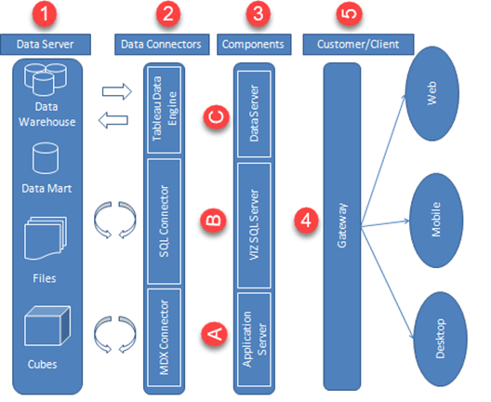

Tableau Architecture Diagram

Let's study the different components of Tableau Architecture

### Data Server

The primary component of Tableau Architecture is the Data sources it can connect to it.

Tableau can connect to multiple data sources. These data sources can be on-premise or remotely located. It can connect to a database, excel file, and a web application all at the same time. Tableau can connect data from heterogeneous environments. It can blend the data from multiple data sources. It can also make the relationship between various types of data sources.

## Data Connectors

The Data Connectors provide an interface to connect external data sources to Tableau Data Server.

Tableau has in-built ODBC/SQL connector. This ODBC Connector can connect to any databases without using their native connector. Tableau has an option to select both live and extract data. Based on the usage, one can be easily switched between extracted and live data.

* **Live Connection or Real time data:**Tableau can connect to real time data by linking to the external database directly. It uses the infrastructure of existing database system by sending dynamic MDX (Multidimensional Expressions) and SQL statements. This feature can link to the live data with Tableau rather than importing the data. It makes good the investment done by an organization on a fast and optimized database system. In many enterprises, the size of the database is huge and is updated periodically. In those cases, Tableau works as a front-end visualization tool by connecting to the live data.
* **Extracted or In-memory data:**Tableau has an option to extract the data from external data sources. We can make a local copy in the form of tableau extract file. It can extract millions of records in Tableau data engine with a single click. Tableau's data engine uses storage such as RAM, ROM and cache memory to store and process data. Using filters, Tableau can extract few records from a huge dataset. This improves the performance, especially while working on massive datasets. Extracted or in-memory data allows the users to visualize the data offline, without connecting to the data source.

## Components of Tableau Server

The different components present in a Tableau server are:

* Application Server
* VizQL Server
* Data Server

**A) Application Server:**

The application server is used to provide the authentications and authorizations. It handles the administration and permission for web and mobile interfaces. It assures security by recording each session id on Tableau Server. The administrator can configure the default timeout of the session in the server.

**B) VizQL Server:**

VizQL server is used to convert the queries from the data source into visualizations. Once the client request is forwarded to VizQL process, it sends the query directly to data source and retrieves information in the form of images. This image or visualization is presented to the user. Tableau server creates a cache of visualization to reduce the load time. The cache can be shared across many users who have the permission to view the visualization.

**C) Data Server:**

Data server is used to manage and store the data from external data sources. It is a central data management system. It provides metadata management, data security, data storage, data connection and driver requirements. It stores the relevant details of data set such as metadata, calculated fields, sets, groups, and parameters. The data source could extract data as well make live connections to external data sources.

## Gateway

The gateway channelizes the requests from users to Tableau components. When the client makes a request, it is forwarded to external load balancer for processing. The gateway works as a distributor of processes to various components. In case of absence of external load balancer, gateway also works as a load balancer. For single server configuration, one primary server or gateway manages all the processes. For multiple server configurations, one physical system works as primary server while others are used as worker servers. Only one machine can be used as a primary server in Tableau Server environment.

## Clients

The dashboards and visualizations in Tableau server can be viewed and edited using different clients. The Clients are Tableau Desktop, web browser and mobile applications.

|  |  |
| --- | --- |
| **Clients** | **Environment** |
| Tableau Desktop | Tableau Desktop is a business analytics tool. It helps to create, view and publish dashboards in Tableau Server. Users can access various data sources and build visualizations in Tableau Desktop. |
| Mobile | The dashboards from the server can be interactively visualized using mobile browsers and applications. The browser and application can be used to view and edit the contents in the workbook. |
| Web | Web browsers such as Google Chrome, Safari, Firefox and internet explorer support the Tableau server. The contents and visualizations in the dashboard can be edited through these web browsers. |

## Summary:

* The architecture of Tableau Server is designed to connect different data sources securely.
* Data Server is the first layer in the architecture. It helps Tableau to connect data in various heterogeneous environments.
* Data connector is the second layer. It helps to connect to various databases using its ODBC connector.
* Tableau can connect the real time live data by connecting the database directly. It can also extract a local copy of data through its in-memory data store for faster processing.
* The components such as Application Server, VizQL Server, and data server act as the third layer.
* The application server is used for authentications and authorizations.
* VizQL is used to convert the SQL query into visualizations.
* Data Server is a centralized data management system used in the architecture.
* A gateway is used to distribute the processes into different components.
* The fourth layer of the architecture are the clients such as Tableau Desktop, web and Mobile.

# 3.How to Download & Install Tableau Public (Free) & Desktop (Trial)

Tableau is available in 2 versions

1. Tableau Public (Free)
2. Tableau Desktop (Commercial)

Here is a detailed comparison between the two

|  | **Tableau Desktop** | **Tableau Public** |
| --- | --- | --- |
| **Pricing** | Personal Edition - $35 per month Professional Edition - $70 per month | Free and Open Source |
| **Data Source Connection** | Connect to any data source files including databases, web applications and more | Connect to Excel and text files |
| **Publish/Save** | Can be saved as a local file and can be published in Tableau Server and Tableau Online | Can be published only in Tableau Public profile |
| **OS** | Windows and Mac | Windows and Mac |
| **Security** | Data and Visualizations are secured | Data and visualizations are not secured as it is available in public |
| **Usage Details** | Professional and Enterprise level | Personal level |
| **Data Extract** | Data can be extracted from various data sources and stored as Tableau extract file | Data cannot be obtained from different data sources as it is limited to connect only excel and text files. |

Note: To execute the examples in these tutorials, you will need access to Tableau Desktop. We will go through the steps the install Tableau Desktop on a Windows Machine. It has a 14-day trial.

In this tutorial, you will learn

* [Download and Install Tableau Public](https://www.guru99.com/download-install-tableau.html#11)
* [Download and Install Tableau Desktop](https://www.guru99.com/download-install-tableau.html#2)

## Download and Install Tableau Public

**Step 1)** Go to <https://public.tableau.com/en-us/s/download> on your web browser. Now you need to enter your email id and click on "**DOWNLOAD THE APP**" button.

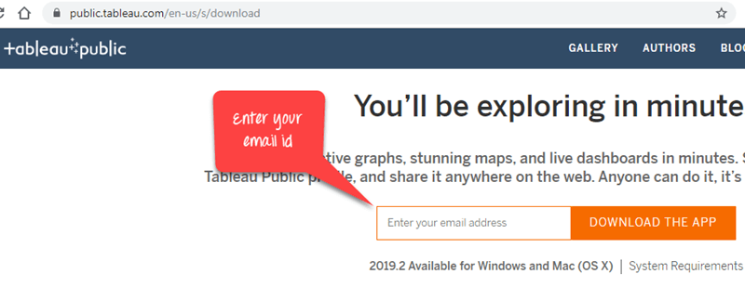

**Step 2)** This will start downloading the .exe file for Windows by default, and you can see the downloading process in the bottom left corner of the website.

[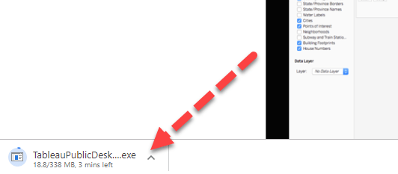](https://www.guru99.com/images/tableau/091119_0459_HowtoDownlo13.png)

**Step 3)** Open the downloaded file. Accept the terms and conditions and click on "Install" button.

[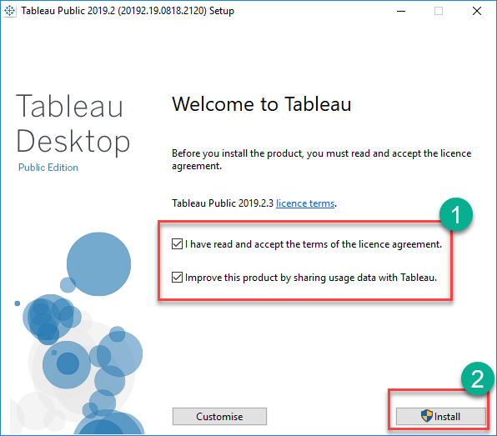](https://www.guru99.com/images/tableau/091119_0459_HowtoDownlo14.png)

**Step 4)** After installation Start Screen of Tableau is shown

[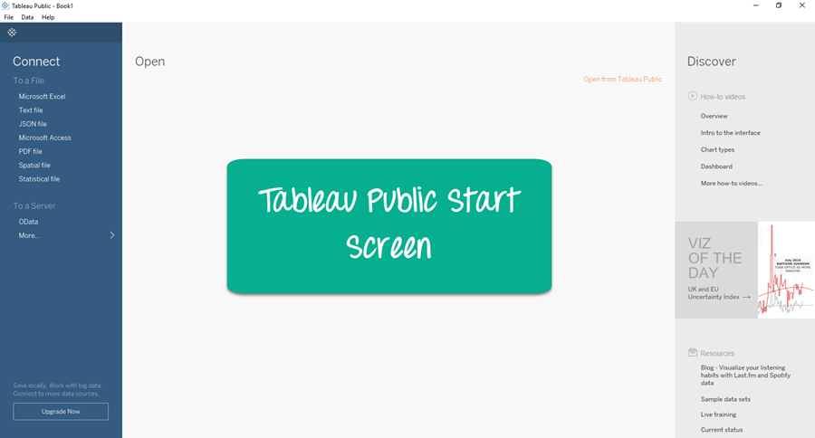](https://www.guru99.com/images/tableau/091119_0459_HowtoDownlo15.png)

## Download and Install Tableau Desktop

**Step 1)** Go to <https://www.tableau.com/products/desktop> on your web browser.

[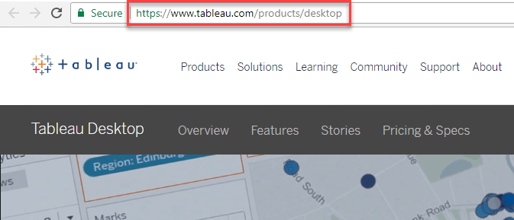](https://www.guru99.com/images/tableau/060818_0459_HowtoDownlo1.png)

**Step 2)** Click on the "TRY NOW" button shown in the top right corner of the website.

**Step 3)** It will redirect to the page where you need to enter your email id and click on "**DOWNLOAD FREE TRIAL**" button.

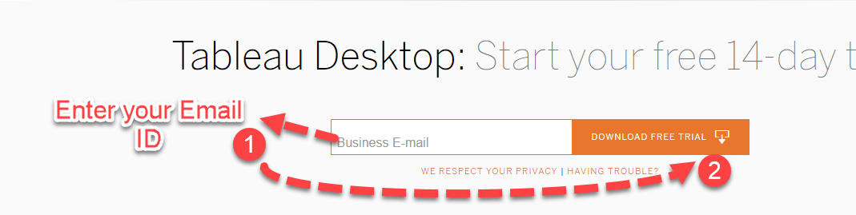

**Step 4)** This will start downloading tableau latest version. An .exe file for Windows is downloaded, and you can see the downloading process in the bottom left corner of the website.

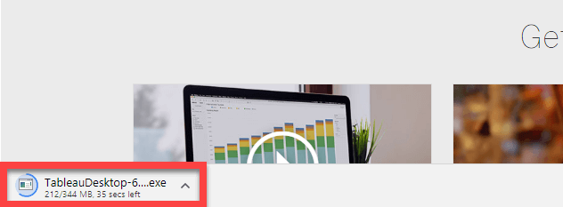

**Step 5)** Open the downloaded file. Check in to accept the terms and conditions and click on "Install" button.

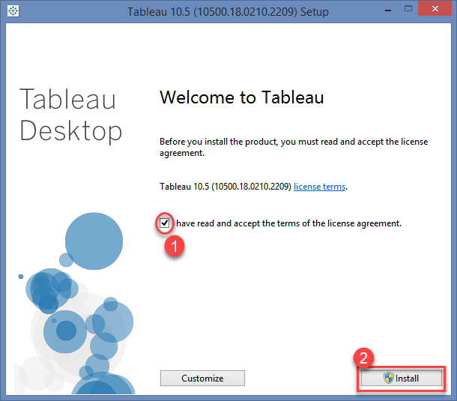

**Step 6)** A optional pop-up message will be shown to get the approval of Administrator to install the software. Click on "Yes" to approve it. Installation of the Tableau Desktop on Windows system starts

**Step 7)**Once the installation is completed, open the Tableau Desktop software.

**Step 8)** In the Registration window

1. Click on Activate Tableau and entire your license details
2. If you do not have a license, enter your credentials
3. Click on Start Trial now

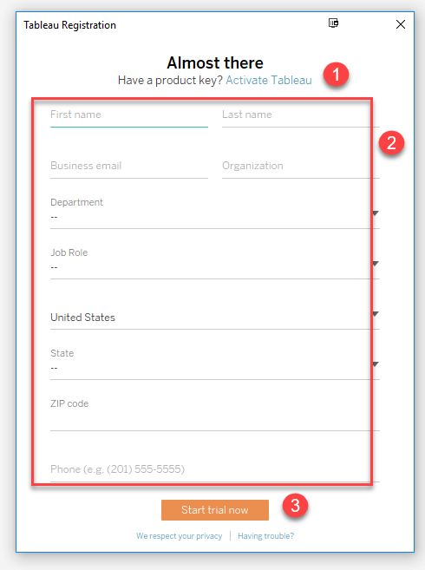

**Step 9)** Wait for registration to complete

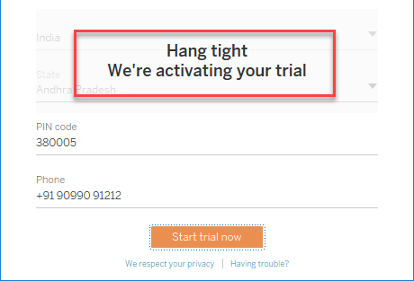

**Step 10)** Start Screen of Tableau is shown

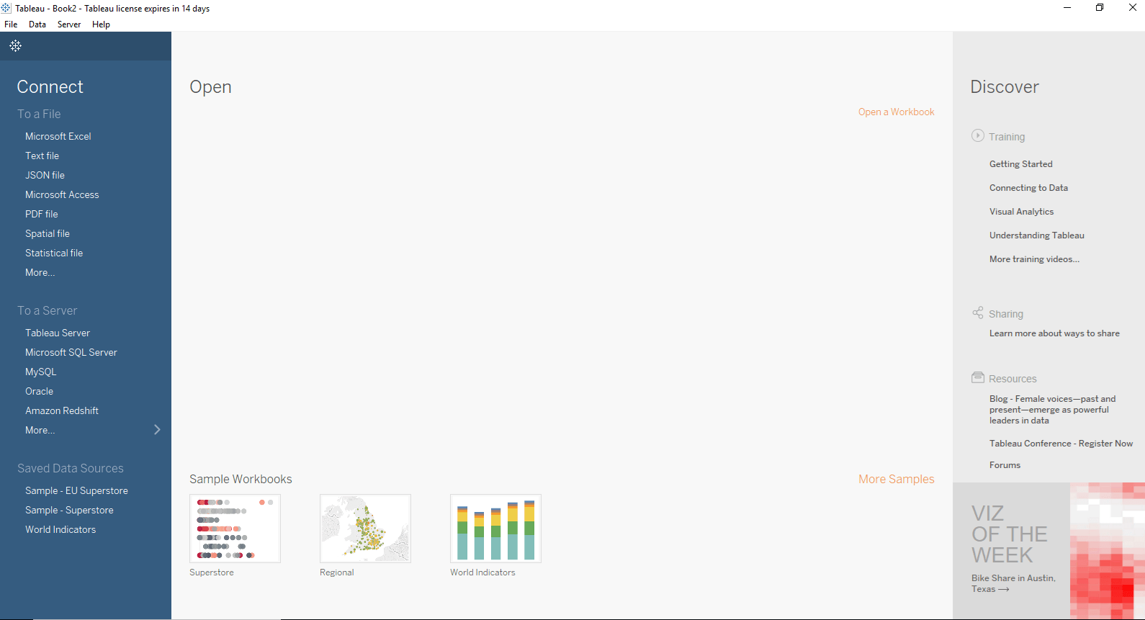

Now you are all set to use the Tableau Desktop in your windows system.

# 4.Introduction to Tableau Desktop Software: Workspace & Navigation

## Tableau Desktop Workspace

In the start screen, go to File > New to open a Tableau Workspace

The Tableau Desktop Workspace consists of various elements as given in the figure:

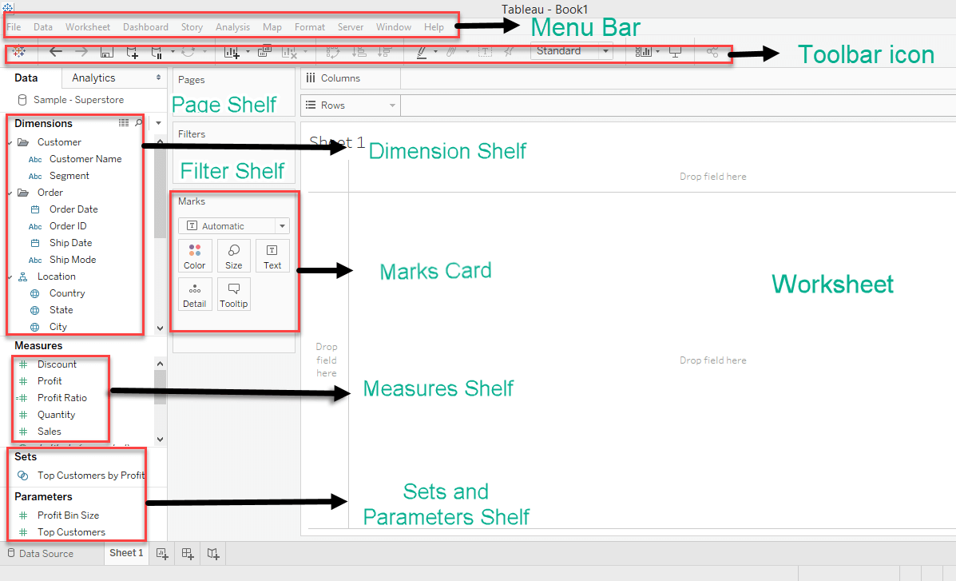

**Menu Bar:**

It consists of menu options such as File, Data, Worksheet, Dashboard, Story, Analysis, Map, Format, Server, and Windows. The options in the menu bar include features such as file saving, data source connection, file export, table calculation options, and design features for creating a worksheet, dashboard, and storyboard.

**Toolbar Icon:**

Toolbar icon present below the menu bar can be used to edit the workbook using different features such as undo, redo, save, new data source, slideshow and so on.

**Dimension Shelf:**

The dimensions present in the data source can be viewed in the dimension shelf.

**Measure Shelf:**

The measures present in the data source can be viewed on the measure shelf.

**Sets and Parameters Shelf:**

The user-defined sets and parameters can be viewed in the sets and parameter shelf. It can also be used to edit the existing sets and parameters.

**Page Shelf:**

Page shelf can be used to view the visualization in video format by keeping the relevant filter on the page shelf.

**Filter Shelf:**

The filters that can control the visualization can be placed on the filter shelf, and the required dimensions or measures can be filtered in.

**Marks Card:**

Marks card can be used to design the visualization. The data components of the visualization such as color, size, shape, path, label, and tooltip used in the visualizations can be modified in the marks card.

**Worksheet:**

The worksheet is the place where the actual visualization can be viewed in the workbook. The design and functionalities of the visual can be viewed in the worksheet.

**Tableau Repository:**

Tableau repository is used to store all the files related to tableau desktop. It includes various folders such as Bookmarks, Connectors, Datasources, Extensions, Logs, Mapsources, Services, Shapes, TabOnlineSyncClient and Workbooks. My Tableau repository is usually located in the file path C:\Users\User\Documents\My Tableau Repository.

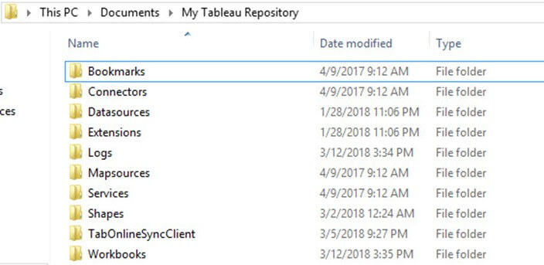

## Tableau Navigation

The navigation of workbook is explained below.

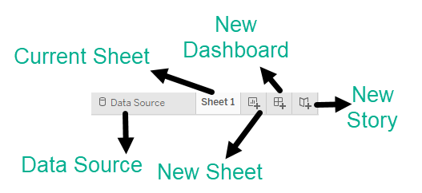

**Data Source:**

The addition of new data source of modification of existing data source can be done using the 'Data Source' tab present at the bottom of the Tableau Desktop Window.

**Current Sheet:**

Current Sheet can be viewed with the name of the sheet. All the sheets, dashboards and story board present in the workbook can be viewed here.

**New Sheet:**

The new sheet icon present in the tab can be used to create a new worksheet in the Tableau Workbook.

**New Dashboard:**

The new dashboard icon present in the tab can be used to create a new dashboard in the Tableau Workbook.

**New Storyboard:**

The new storyboard icon present in the tab can be used to create new storyboard in the Tableau Workbook.

**5.Tableau Data Connections to Databases and Multiple Sources**

In this tutorial, you will learn-

* [Connecting to various data sources](https://www.guru99.com/tableau-data-connections.html#1)
* [Connection to Text File](https://www.guru99.com/tableau-data-connections.html#3)
* [Connecting to Excel File](https://www.guru99.com/tableau-data-connections.html#4)
* [Connection to Database](https://www.guru99.com/tableau-data-connections.html#5)
* [Connection to Websites](https://www.guru99.com/tableau-data-connections.html#6)
* [Connecting to Tableau Server](https://www.guru99.com/tableau-data-connections.html#7)
* [Data Relationship](https://www.guru99.com/tableau-data-connections.html#8)
* [Data Sorting](https://www.guru99.com/tableau-data-connections.html#9)
* [Replacing Data Source](https://www.guru99.com/tableau-data-connections.html#10)

## Connecting to various data sources

Tableau can connect to various types of data sources. It can connect to text files, excel files, PDF files, etc. It can also connect to various databases using its ODBC connector. Tableau has the capability to connect to servers and web connectors. In this tutorial, we will learn about the connection procedures from various data sources.

Following screenshot gives the exhaustive connection types Tableau supports

## https://www.guru99.com/images/tableau/060818_0511_TableauConn1.jpgConnection to Text File

**Step 1)**Click on the "Text File" option given in the data tab.

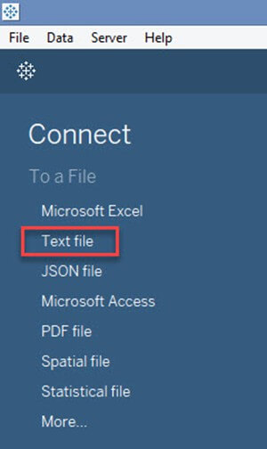

**Step 2)**In the next screen,

1. Select the [SuperStore.csv](https://drive.google.com/uc?export=download&id=1xV_3j-kn7UbHBpLd47DgY5g6obdbmQk1)

2. Click on "Open" Option. This will connect the text file into Tableau.

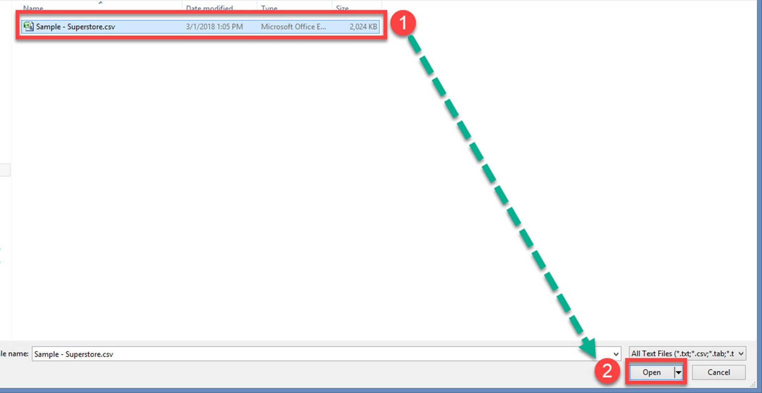

In the left pane you will see the CSV file.

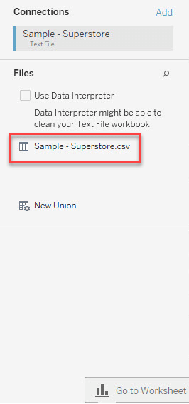

## Connecting to Excel File

**Step 1)**Click on the "Microsoft Excel" option given in the data tab.

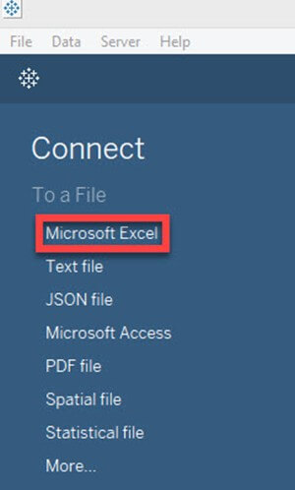**Step 2)**In the next screen,

1. Select the [SuperStore.xlxs](https://drive.google.com/uc?export=download&id=1wq60dEFV3NUPqpwXaMKtmQPnxzqZHR5F)
2. Click on "Open" Option.

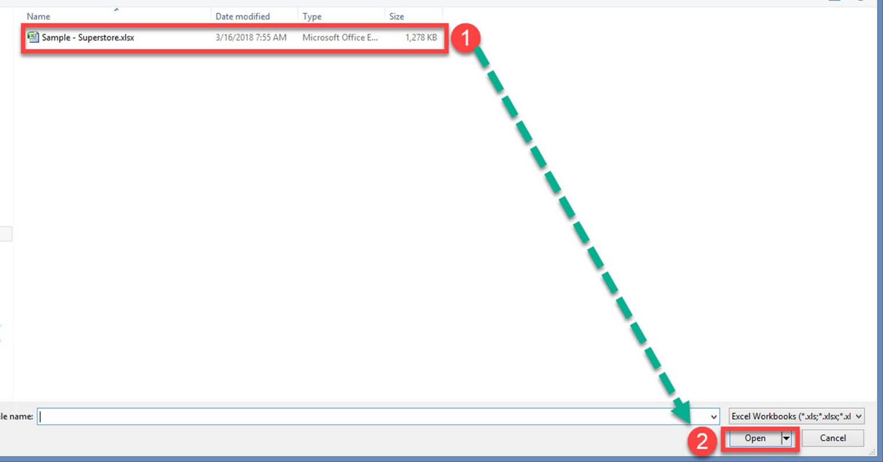**Step 3)**It connects the excel file into Tableau. The sheets present in the excel file is shown on the left side of the window.

## https://www.guru99.com/images/tableau/060818_0511_TableauConn7.jpgConnection to Database

**Step 1)** Click on the required database connection given in the data tab. For example, if you want to connect to MySQL database, click on the "MySQL" Option.

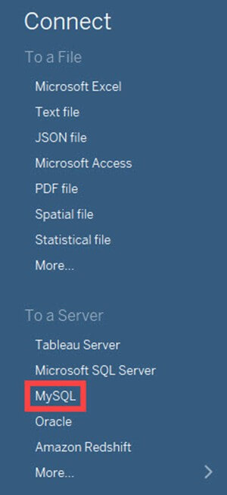**Step 2)** This will open MySQL connection window.

1. You can enter the MySQL server name and edit the "Port" if needed.
2. Enter the username and password used to connect the database.
3. Click on the "Sign in" button to connect to the database.

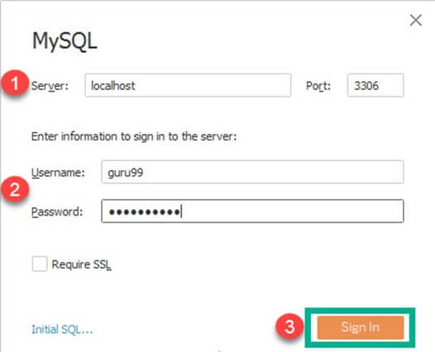This procedure connects the database into the Tableau. You can select the tables from the database and import it into Tableau. You can join multiple tables by creating a relationship between them.

## Connection to Websites

Tableau can connect to websites using web connector. The connection procedure is given as follows.

**Step 1)**In this window,

1. Click on "More" option in the data tab.
2. Select "Web Data Connector" from the list.

## https://www.guru99.com/images/tableau/060818_0511_TableauConn10.jpg**Step 2)** This will open a Web Data Connector window where you need to enter the web connector details. https://www.guru99.com/images/tableau/060818_0511_TableauConn11.jpgConnecting to Tableau Server

Tableau Server can store extracted data sources and database connections. In enterprise level, it is important to keep all the required data connections in Tableau Server. It helps all the users of the enterprise to connect to the data source easily. The data sets in the Tableau Server can connect to Tableau Desktop by following the given procedures.

**Step 1)**Select the "Tableau Server" option given in the data tab.

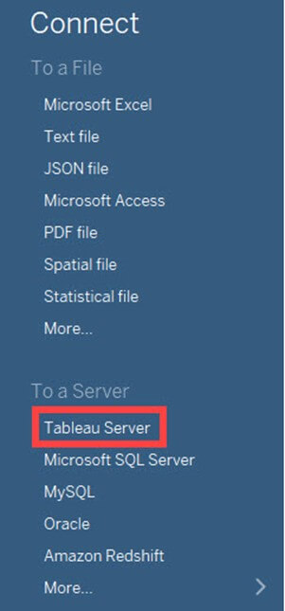

**Step 2)** This opens the Tableau Server Sign in window. Click on 'Tableau Online' option. 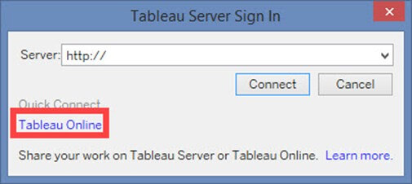**Step 3)**It opens Tableau Online Sign In Window.

1. Enter the registered email id and password.
2. Click on 'Sign In' button.

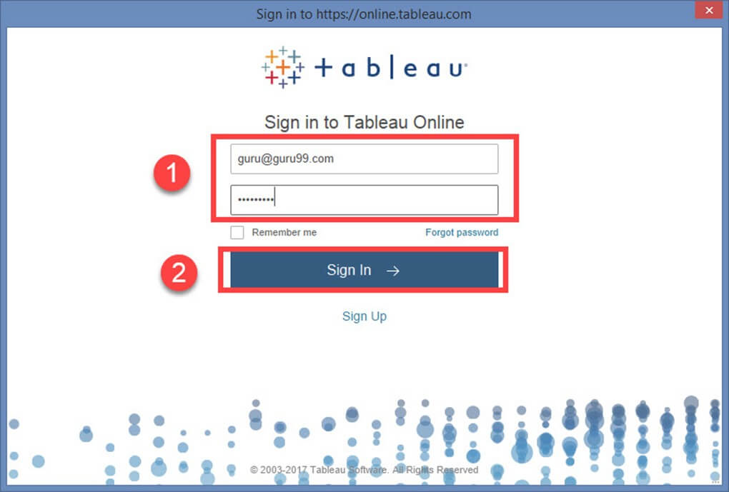**Step 4)**This will connect Tableau Server into Tableau Desktop.

1. Select the data set as shown in the figure.
2. This will import the dataset into Tableau.

## https://www.guru99.com/images/tableau/060818_0511_TableauConn15.jpgData Relationship

A relational Database/Excel file consists of multiple Tables/sheets. These multiple tables/sheets can be connected to each other in Tableau. This connection is established by 'Join' or 'Union' feature present in Tableau. The relationship between data in two or more tables needs to be specified while joining tables.

**Joins:**

Tableau can "join" tables. It can join up to 32 tables in a data source. While joining, the relationship between two or more tables can be specified. The tables present in the data source can be related to each other using the joins such as inner join, left join, right join and outer join. The functionalities of Join types are explained in the table below,

|  |  |  |  |
| --- | --- | --- | --- |
| **Inner Join** | **Left Join** | **Right Join** | **Outer Join** |
| It joins all the common records between two tables or sheets. The joining condition can be given based on the primary key. One or more joining conditions can be specified to join the tables. Many tables can be joined together in Tableau for visualization. | A left join is used to join all the records from a left table and common records from the right table. One or more join conditions can be specified to left join two different tables. | A right join is used to join all the records from a right table and common records from left table. Based on the requirements, one or more joining condition can be set. | An Outer join is used to join all the records from both left and right table. Joining conditions can be set to join common records. |

Let's see an example of Join

**Step 1)** Once an Excel is connected, Drag the required sheet into data window as shown in the figure.

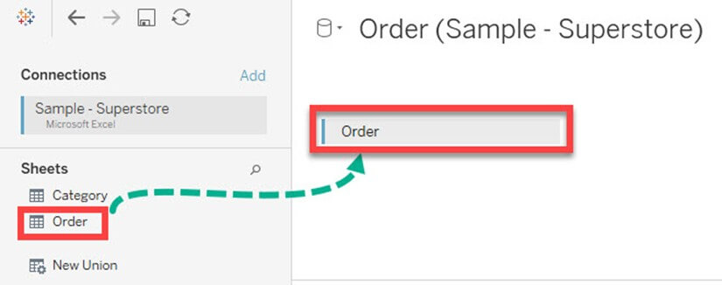**tep 2)** You can connect multiple sheets by dragging the sheets into the data window. The relationship between the sheets can be given by connecting the data fields.

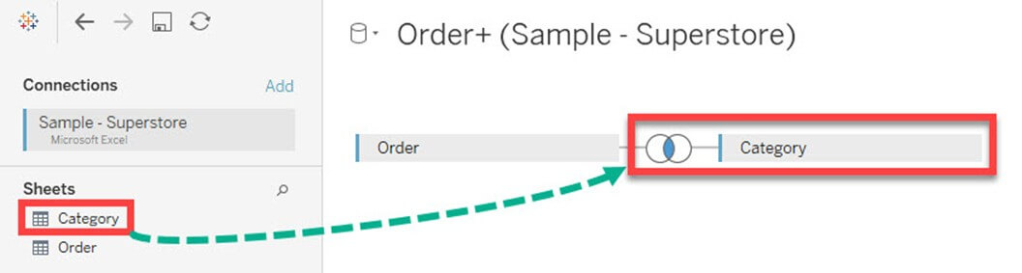**Step 3)**In the data sheet

1. Click on the "Join" option as shown in the figure. By default, Tableau joins two tables by connecting a relationship between common column present in it.
2. You can edit the relationship by selecting the required joining Condition.
3. You can add one or more data relationship between the sheets or tables.

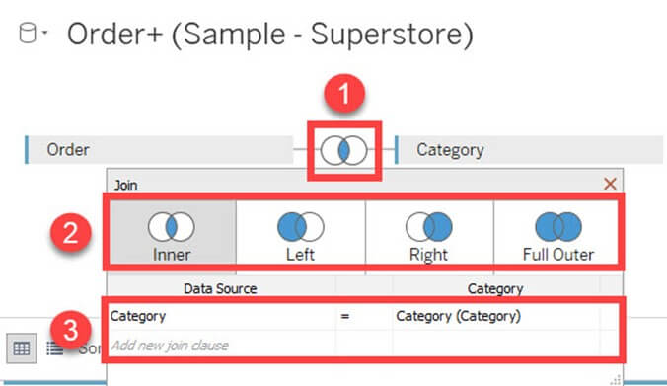**Union**

Union is used to append the data from two or more tables. In most of the cases, tables with same headers are appending together using union function. Joining conditions are not required while union two or more tables. The procedure to union tables are given as follows.

**Step 1)**Drag any of the sheet into data window as shown in the figure.

**Step 2)**Right click on the sheet and select "Covert to Union" option.

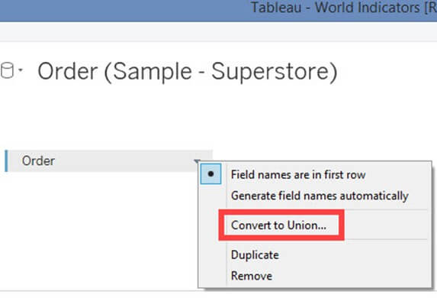**Step 3)** In the data union window.

1. Drag other sheets which need to be union.
2. Click on 'OK' to append or union all the sheets present in the window.

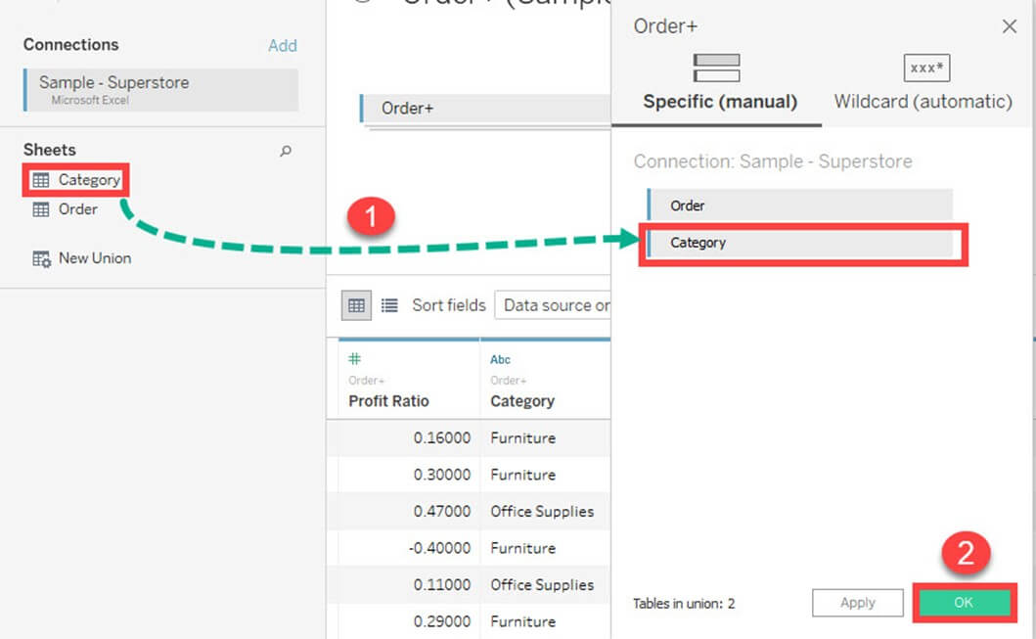A data relationship is not needed to union sheets present in the data source.

## Data Sorting

Data present in the data source can be sorted based on the user requirement. It can be sorted using data source order, ascending, descending, ascending per table and descending per table.

Once the data is connected to Tableau, data sorting can be done using the "Sort Fields" option. The option is present in the "Data Source" tab.

## https://www.guru99.com/images/tableau/060818_0511_TableauConn22.jpgReplacing Data Source

Tableau can connect multiple data sources in a single workbook. The different data sources can be used to build various sheets and dashboards in Tableau. In some cases, data sources need to be replaced with updated file. Tableau has a data source replacing feature which can replace data sources. This feature does not affect the already built visualizations using the old data source. It is important to keep or replace all the used dimensions and measures while replacing the data source.

The data source connected in Tableau can be replaced with another data source. The procedure for replacing data source is given as follows.

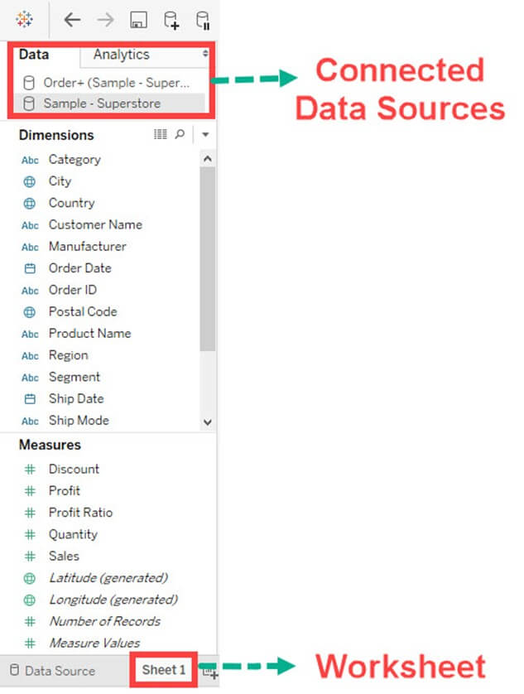**Step 2)**

1. Select the Data Source to be replaced.
2. Right-click on the data source and select "Replace Data Source" option.

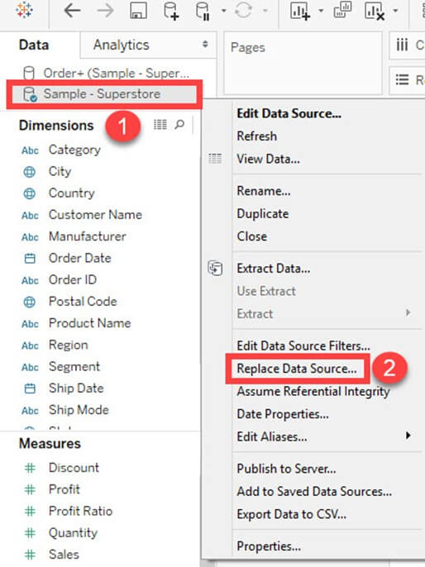**Step 3)**It opens the data source replacement window.

1. Select the current

2. Select replacement data source.

3. Click on "OK" to replace the data source.

## https://www.guru99.com/images/tableau/060818_0511_TableauConn25.jpgSummary

* Tableau can connect to various data sources like Excel, databases, and websites.
* It can join various sheets or tables present in the data source.
* The joining conditions used in Tableau are an inner join, right join, left join and outer join.
* Tableau can connect and join various sheets present in an excel file.
* The database can be connected to Tableau by connecting the database server.
* Tableau can connect websites by using web connector.
* Data sorting is available in the Tableau's data source Tab.
* Tableau Server can be connected to Tableau Desktop.

# 6.Types of Filters in Tableau: Condition by Formula, Extract, Context

Data can be organized and simplified by using various techniques in Tableau. We will use the "Sample– Superstore.csv" text file for demonstration in this tutorial.

In this tutorial you will learn

* [Types of Filters:](https://www.guru99.com/filter-data-tableau.html#2)
* [Extract Filters:](https://www.guru99.com/filter-data-tableau.html#3)
* [Filter condition in Tableau](https://www.guru99.com/filter-data-tableau.html#4)
* [Filter Condition by Formula:](https://www.guru99.com/filter-data-tableau.html#5)
* [Data Source Filter:](https://www.guru99.com/filter-data-tableau.html#6)
* [Context Filter:](https://www.guru99.com/filter-data-tableau.html#7)
* [Dimension Filters:](https://www.guru99.com/filter-data-tableau.html#8)

## Types of Filters:

The filters can be applied in a worksheet to restrict the number of records present in a dataset. Various types of filters are used in Tableau Desktop based on different purposes. The different types of filters used in Tableau are given below. The name of filter types are sorted based on the order of execution in Tableau.

1. Extract Filters
2. Data Source Filters
3. Context Filters
4. Dimension Filters
5. Measure Filters

### Extract Filters:

Extract filters are used to filter the extracted data from data source. This filter is utilized only if the user extracts the data from data source.

Once the text file is connected to Tableau, you can see the live and extract option in the top right corner of data source tab. Live Connection directly connects to a data source. Extract connection extracts the data from data source and creates a local copy in Tableau repository. The procedure for creating an extracting filter is given as follows.

**Step 1)** After connecting the text file into Tableau,

* Click on "Extract" radio button as shown in the figure.

This will create a local copy in Tableau repository.

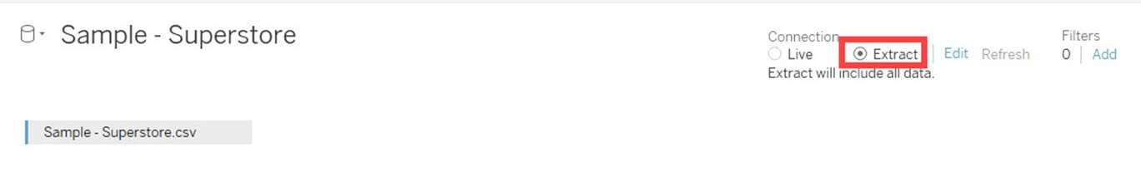**Step 2)**Next**,**

1. Click on the 'Edit' option placed near to Extract button.
2. It opens "Extract data" window. Click on 'Add' option present in the Window.

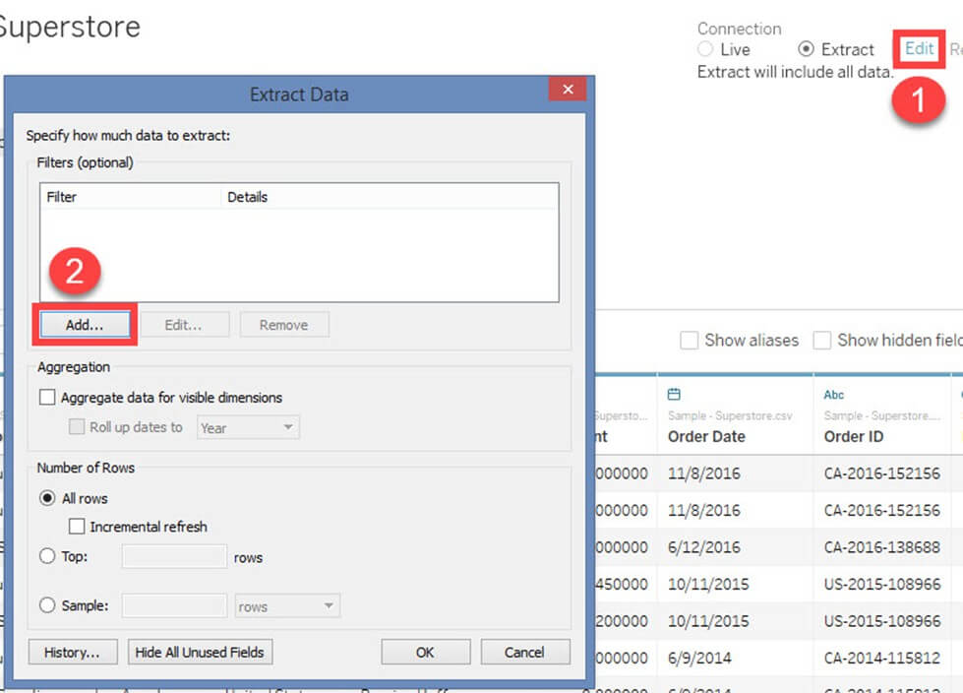Step 3) "Add Filter" Window is open to select the filter conditions.

You can choose any of the fields and add as extract filter. In this example, we have selected'Category' as extract filter.

1. Select 'Category' from the list
2. Click on 'OK.'

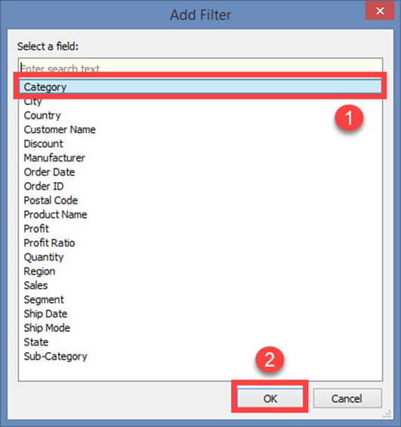Once you click on OK button, it opens a filter window. 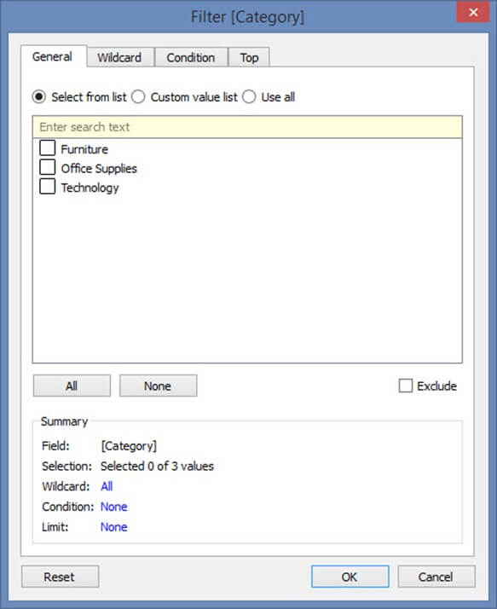The filter window has multiple options to filter 'Category' based on various use case. All the use cases and its filter conditions are explained below.

## Filter condition in Tableau

**Use Case 1: Select from List**

By default, filter window opens the "Select from List" option. You can include or exclude the members present in the field using this option.

To include you can

1. Select the members
2. Click on OK.

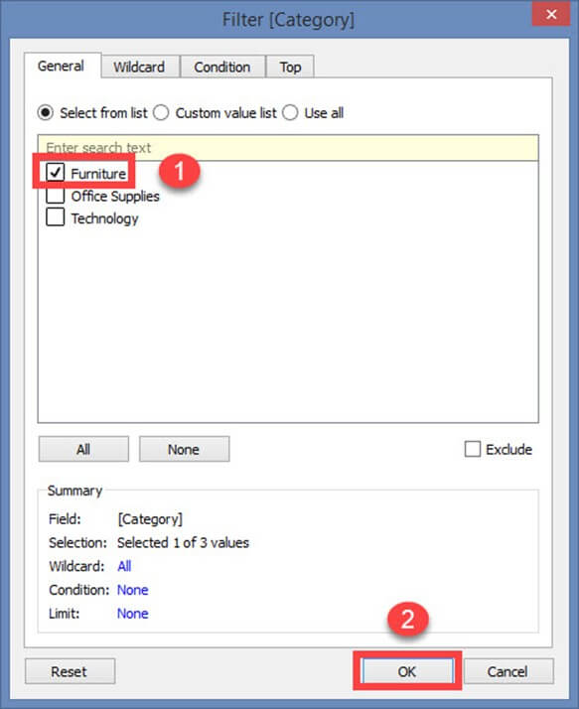To exclude the selected members,

1. Click on exclude checkbox
2. Select the members to exclude
3. Click on OK.

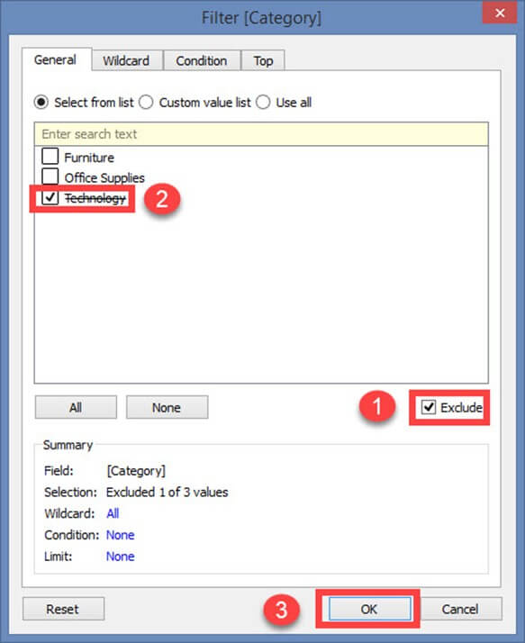There are two more option in the "Select from List".

1. All
2. None

**All:**

This option includes or excludes all members present in the field. In this example, all members are included by clicking on "All" option.

**Step 1)**

1. Select 'All' option.
2. Click on OK

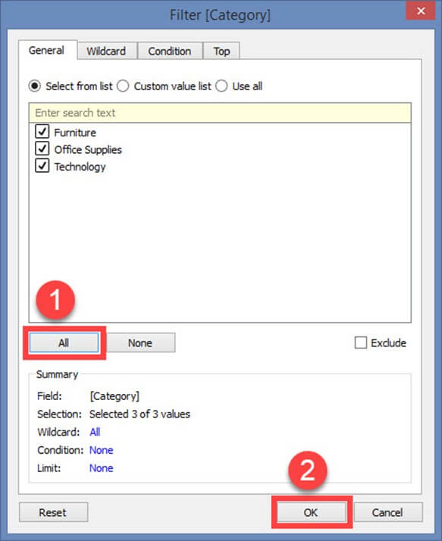**Step 2)**Next**,**

1. It shows extract data filter. The filter condition is also added in the extract filter window.
2. Click on OK to add the extract filter.

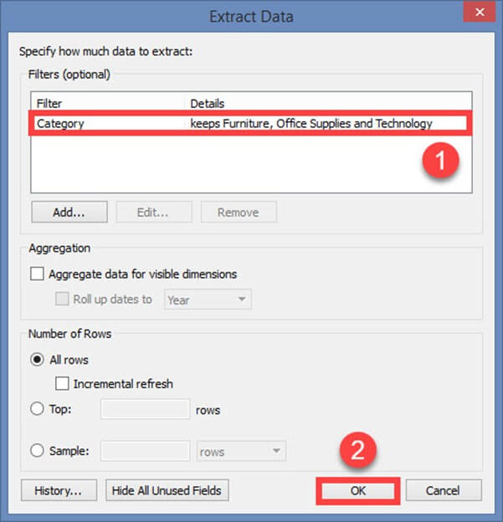To exclude all the members in the list, first, click on 'Exclude' button. Then select 'All' option and click on OK. This procedure adds the filter in extract data filter window. 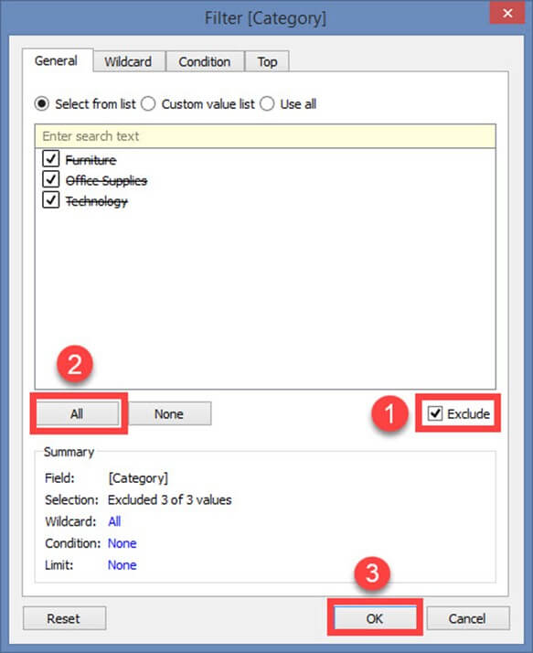**None:**

If you want clear all the selection made in the filter window and start a new selection, you can use this 'none'option. None option clears all the selection made in the filter window. Once it is cleared you can select the new members.

1. Click on the 'None' option. Select the new members to be added as filter.
2. Click on OK to add the extract filter.

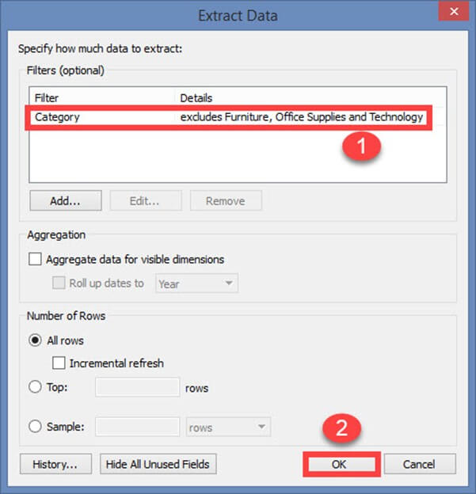**Use Case 2: Custom Value List**

A custom value list allows the user to type the member name and filter the field accordingly. A custom value list can be created by following the given procedure.

**Step 1)**In the Filter Screen

1. Click on "Custom value list" radio button.
2. Type the member name.
3. Click on '+' symbol to add the name in the list.
4. You can add multiple members in the list and click on OK

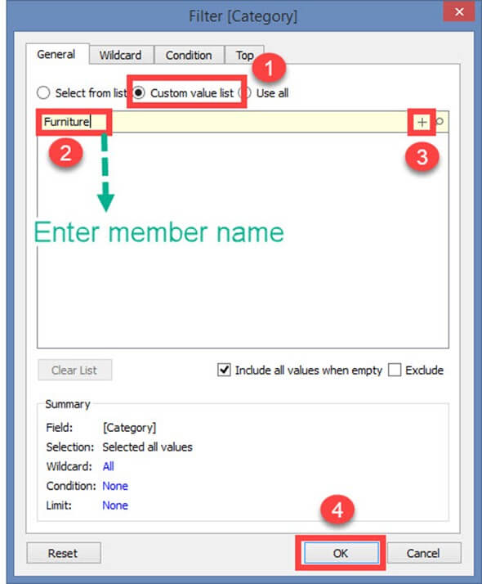There is an option in the window "Include all values when empty." It can be selected to include all values present in the field when the selected member has no data. 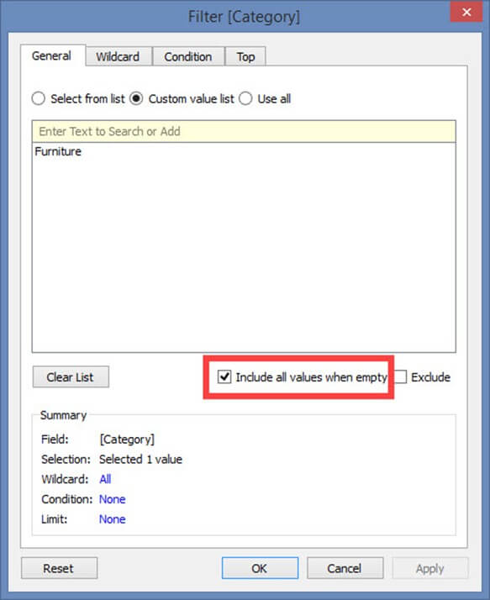Clear List option clears the customs value list. 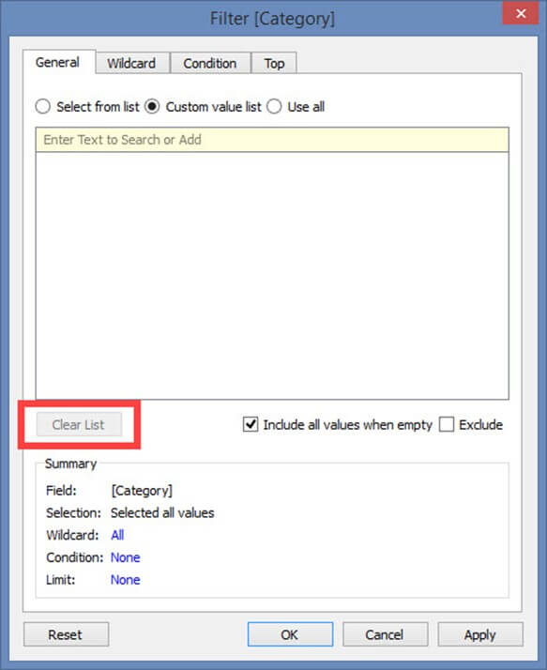**Use Case 3: Use all**

This option selects all the members present in the field.

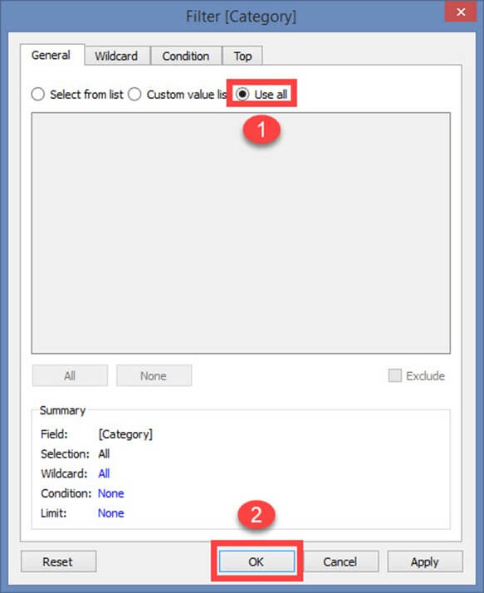**Use case 4: Wildcard**

Wildcard option is used to filter the fields based on given wildcard match. Users can type the character and filter the field based on the match. The different types of matches are given as follows.

|  |  |
| --- | --- |
| **Contains** | Select the members if the member name contains typed characters. |
| **Starts with** | Select the members if the member name starts with typed characters. |
| **Ends with** | Select the members if the member name ends with typed characters. |
| **Exactly matches** | Select the members if the member name exactly matches with typed characters. |

**Step 1)**

1. Select the "Wildcard" tab.
2. Type the characters to match.
3. Select the type of match. In this example "Contains" match type is selected.
4. Click on OK.

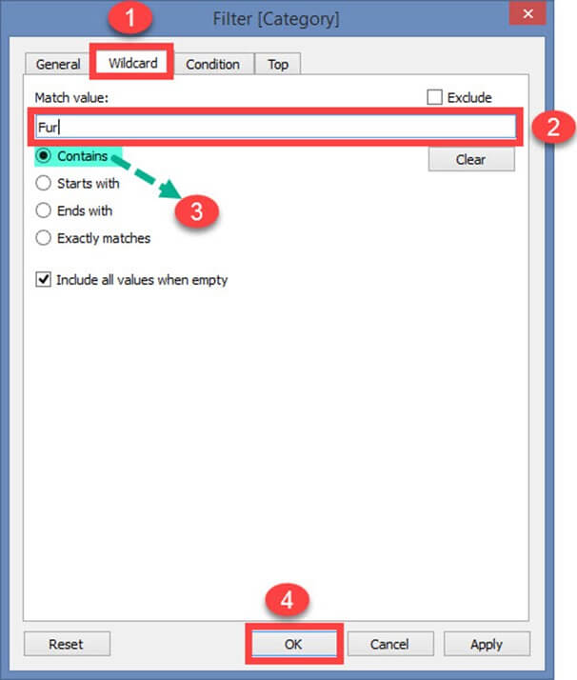

**Use Case 5: Filter on Condition**

This option is used to filter the data set by giving several conditions. Filer condition based on field is given below.

**By Field:**

1. Select the 'Condition' tab in Filter Window.
2. Click on radio button 'By field.'
3. Select the name of the field to be filtered from the drop-down list.
4. Select the aggregation type like Sum, average and median from the drop-down list.
5. Choose the operator from the drop-down.
6. Enter the value to filter the selected field.
7. Click on OK.

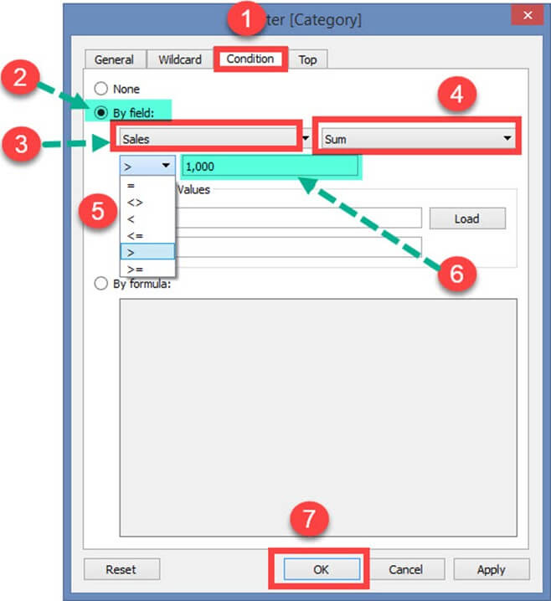In the above example, the dataset is filtered to see the data where the sum of sales is greater than 1000.

**The range of Values:**

This option shows the minimum and maximum value of the selected field by clicking on 'Load' button. It can be used to refer the values.

## https://www.guru99.com/images/tableau/060818_0521_Filterdatai17.jpgFilter Condition by Formula:

You can write a formula to filter the dataset using this option. The procedure is explained below.

**Steps:**

1. Click on radio button 'By formula.'
2. Enter the formula in the box as shown in the figure.
3. Click on Ok.

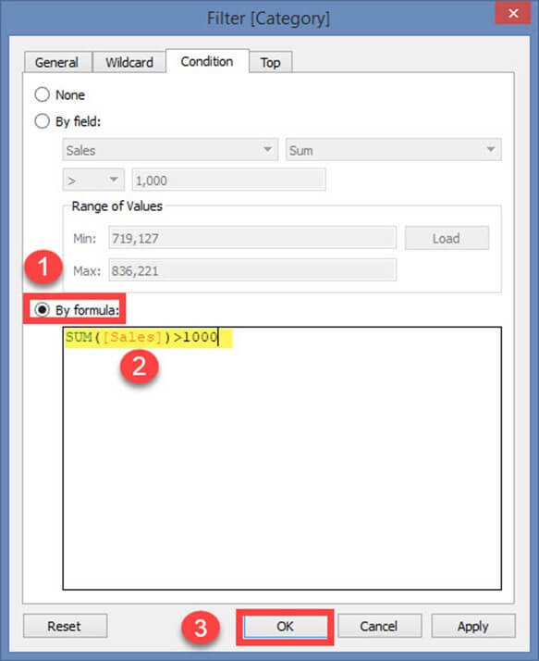In the above example, the written formula filters the data where sum of sales is greater than 1000.

**Use Case 6: Top or bottom filters**

This option is used to select top or bottom 'n' number of records.

**By Field:**

**Step 1)**

1. Select 'Top' tab from the filter window.
2. Click on radio button 'By field'.

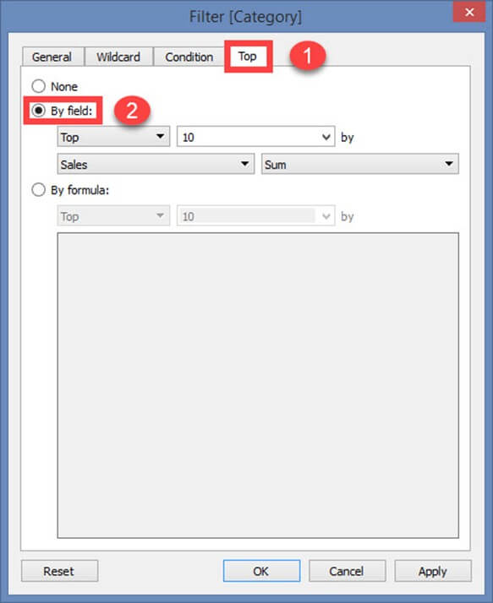**Step 2)**

1. Select 'Top' or 'Bottom'.
2. Choose the number of records.
3. Select the field.
4. Choose the aggregation type.
5. Click on Ok.

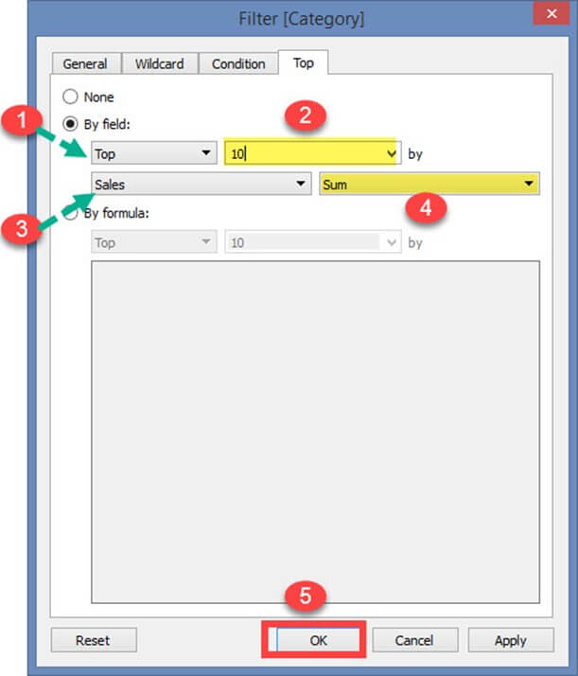In the above example, the filter restricts the data set to show top 10 records based on the sum of sales.

**By Formula:**

The top or bottom condition can also be given through formula.

**Steps:**

1. Click on the radio button 'By Formula'.
2. Select 'Top' or 'Bottom'.
3. Choose the number of records.
4. Enter the formula.
5. Click on OK.

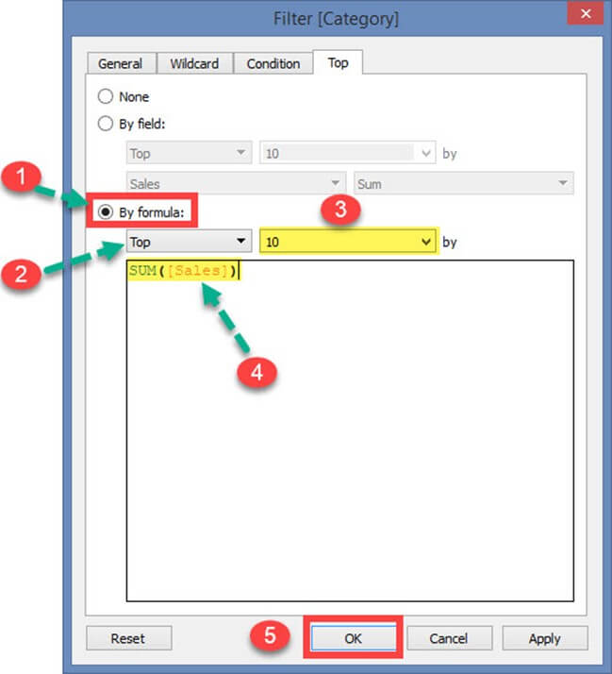In the above example, the formula was written to show top 10 records based on the sum of sales.

### Data Source Filter:

A data source filter is used to filter the data in data source level. It can restrict the records present in the data set. This filter is similar to extract filter on securing the data. But data source filter and extract filter is not linked to each other. **Data source filter works on both live and extracts connection**. The procedure to select data source filter is given as follows.

**Step 1)**Click on the 'Add' button placed on the top right corner of the data source tab.

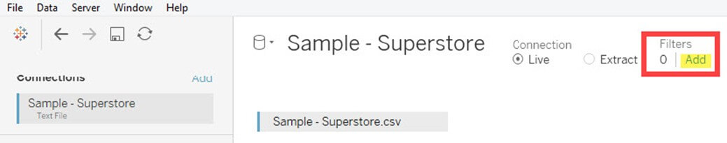**Step 2)** It opens the 'Edit Data Source Filters' Window. Click on 'Add' Option present in the window.

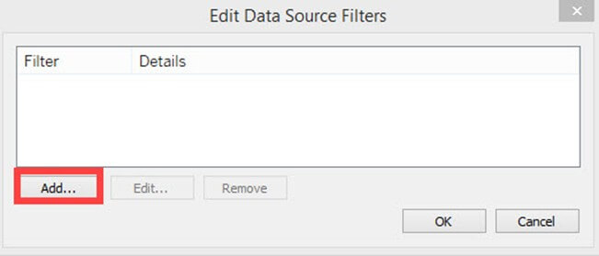After clicking on 'add' button, follow the remaining steps from the topic 'Extract Filters' -> Step 3.

### Context Filter:

A Context filter is an independent filter that can create a separate dataset out of the original data set and compute the selections made in the worksheet. One or more categorical filter that separates the dataset into major parts can be used as a context filter. All other filters used in the worksheet works based on the selection of context filter. The functions of context filters can be explained through an excel sheet.

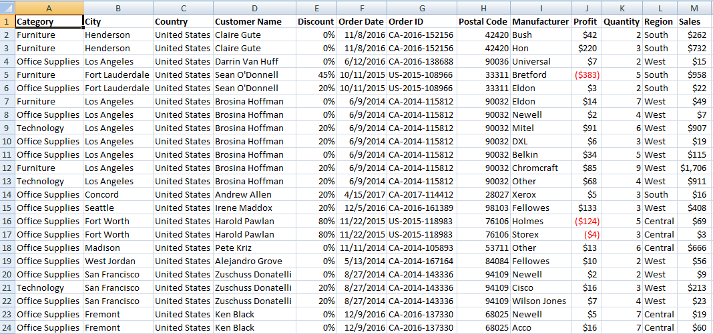The figure shows a sample dataset. From the dataset, it is identified that 'Category' can be used as context filter as it can divide the dataset into major parts. Once the filter is applied to the dataset, the following data can be obtained. 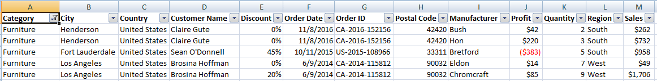When the category "Furniture" is selected, the data available in the particular category is shown in the figure. Other filters that can be applied in the sheet will be dependent on the category filter. This is the basic function of using context filter. Tableau creates a temporary dataset in repository engine based on the context filter selection. Once context filter is selected, all other selections and filters depend on the selection of specific context filter. The temporary table or data set that is created on selecting context filter loads whenever the context filter is changed.

**Apply Context Filters in Worksheet:**

Any dimension can be added as context filter by following the steps given below:

**Step 1)** The dimension to be added as context filter needs to be added in filter section box as given in the image.

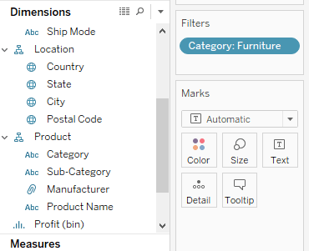

**Step 2)** Right click on the dimension added in the filter section and select "Add to Context" option.

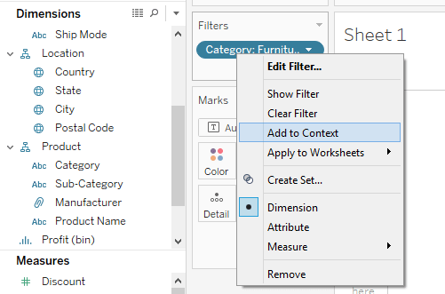

**Step 3)** Once the filter is selected as a context filter, the color of dimension box changes to grey color. This grey color box is an indication of context filter.

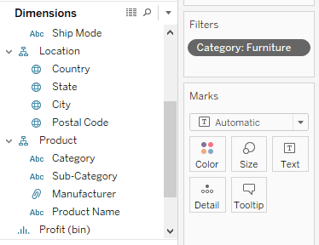**Removing Context Filter:**

Any context filter can be changed back to normal filter by selecting the "Remove from Context" option which is available when right-clicking on the dimension. The color of dimension box will also change back to blue color as an indication.

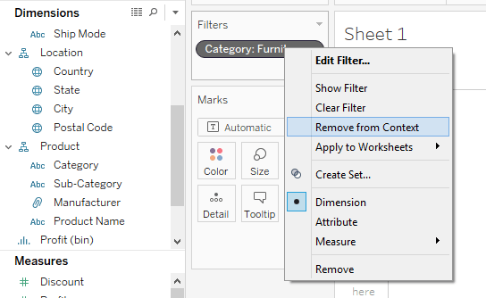**Advantages of Using Context Filters:**

**Improve Performance:**

When context filter is used in large data sources, it can improve the performance as it creates a temporary dataset part based on the context filter selection. The performance can be effectively improved through the selection of major categorical context filters.

**Dependent Filter Conditions:**

Context filters can be used to create dependent filter conditions based on the business requirement. When the data source size is large, context filter can be selected on the major category, and other relevant filters can be executed.

### Dimension Filters:

When a dimension is used to filter the data in a worksheet, it is called as Dimension filter. It is a non-aggregated filter where a dimension, group, sets and bin can be added. A dimension filter can be applied through the top or bottom conditions, wildcard match and formula.

The members present in a dimension can be included or excluded from the list using this filter. Dimension filter can be shown in a sheet or dashboard to change the filter condition dynamically. The process for adding a dimension as the filter is given as follows.

**Step 1)** Go to a worksheet as given in above topics and follow the steps.

1. Select a dimension from the dimension list. In this example 'Category' is chosen from the dimension list. Drag the dimension into 'Filters' box.
2. It opens the 'Filter' Window. Select the member from the list.
3. Click on OK.

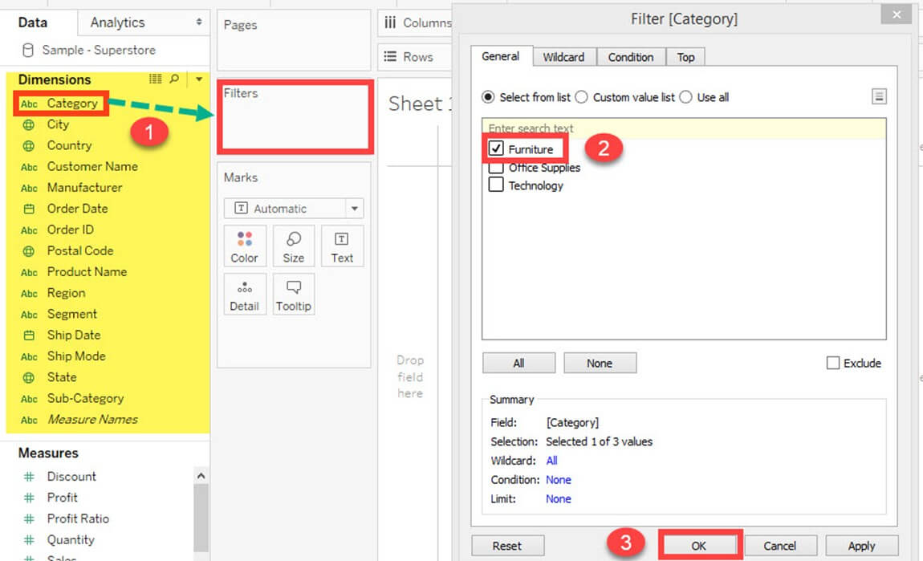The above procedure filters data set to show the records only for category 'Furniture.'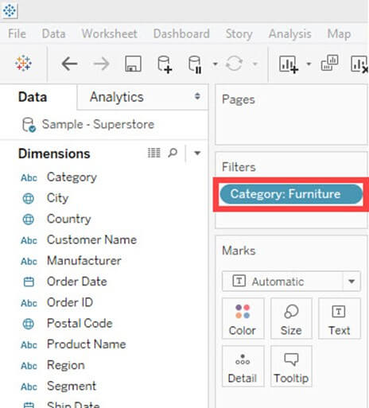**Measure Filter:**

A measure filter can filter the data based on the values present in a measure. The aggregated measure values can be used in measure filter to modify the data. A measure filter can be applied in a worksheet by following the procedure.

**Step 1)**Go to a Worksheet

1. Select a measure present in the Measures tab. In this example, 'Sales' is selected. Drag the measure into 'Filter' box.
2. It opens a 'Filter field' window. Select any of the aggregation from the list. In this example, Sum is taken as aggregation type.
3. Click on 'Next' button.

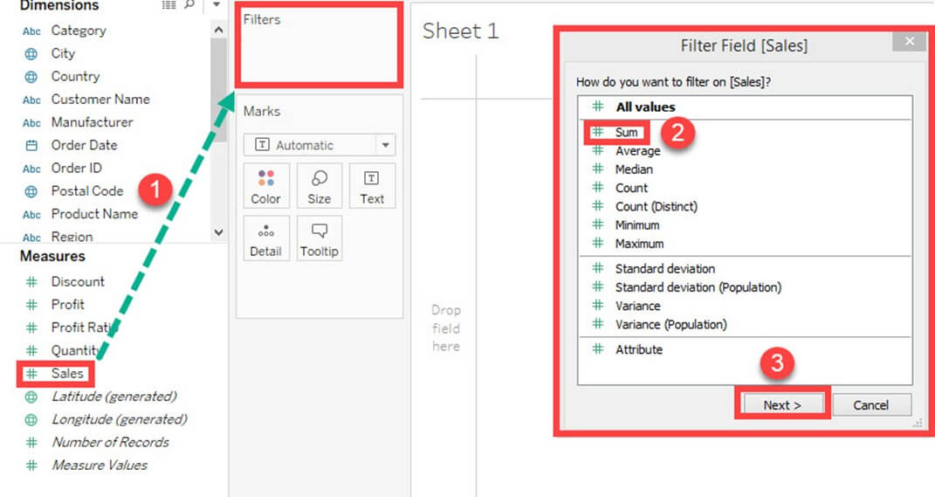**Step 2)** It opens a window where you need to select the range of values. The other types of options present in the window are given as follows.

|  |  |
| --- | --- |
| **Range of values** | Minimum and maximum range of measure value can be given and filtered. |
| **At least** | A minimum value of a measure is given to filter the data. |
| **At most** | A maximum value of a measure is given to filter the data. |
| **Special** | An option to select null or non-null values and filter the data. |

1. Select the range of values. You can modify the upper and lower limit for the range of values.
2. Click on OK.

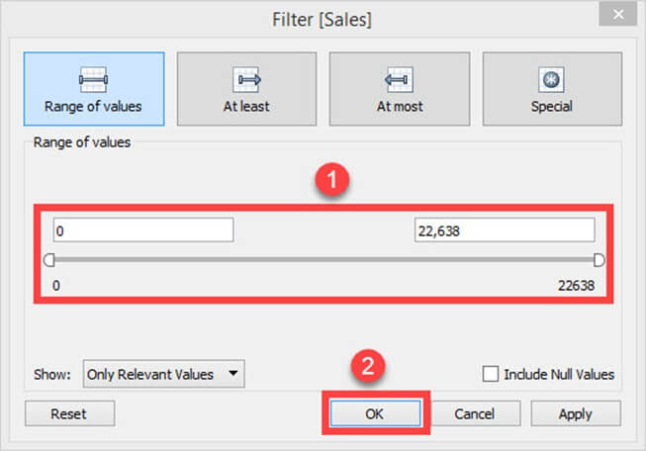The above example filters the data set based on the sum of sales value between 0 and 22638.

**Custom or Quick Filter:**

Filters can be customized based on the user selection. The filters can customize worksheets and dashboards to modify the data dynamically. The procedure to customize the filter is given as follows.

**Step 1)** Add the 'Category 'filter as shown in the topic Dimension filter.

1. Right-click on the filter added.
2. Select 'Show Filter' option.

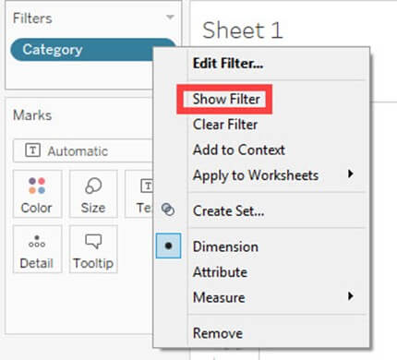**Step 2)** It shows the 'Category' filter box in the right side of the worksheet. By default, the filter shows the multi-value list as shown in the figure. 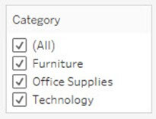

**Step 3)** You can select or unselect members present in the filter and modify the data.

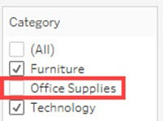**User Filter:**

User filter secure the row level data present in a dataset. It can be used when publishing the workbook on a server. Different filter conditions can be applied for different users. For example, assume there are three departments in a firm namely Furniture, Office Supplies, and Technology. By using the user filter, we can allow the users to show only the data relevant to their department. i.e., Users from 'Furniture' department can only see the data from category 'Furniture'. This can assure the security of row level data. The procedure to apply the user filter is given as follows.

**Step 1)**

1. Click on the Server option present in the Menu bar.
2. Hover over the 'Create User Filter' option.
3. Select the field to create user filter. In this example, the category is selected as user filter.

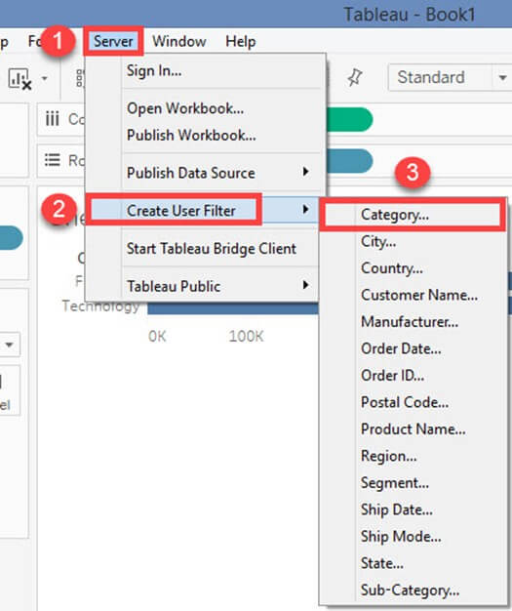**Step 2)**

1. It opens a 'Tableau Server Sign in' window.
2. Click on 'Tableau Online' option present in the window.

**Step 3)**

1. It opens a Tableau Online Sign in Window. Enter your registered email id and password.
2. Click on Sign In option.

**Step 4)**It opens a 'User Filter' window. Follow the below steps to add user filter.

1. Enter a name for the user filter.
2. Select a user form the user's list.
3. Check in the required members need to show for the selected member.
4. Click on OK.

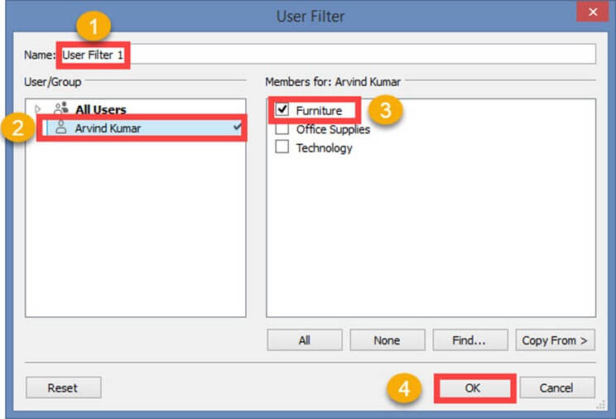It creates a user filter in Tableau. You can view the user filter under sets pane as shown below.

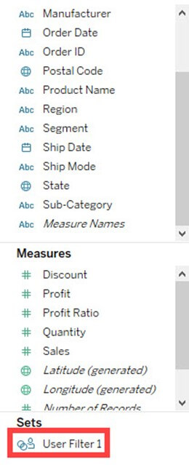When the workbook is published in the server, only the filtered data is shown to the user. User filter can be created for multiple users to secure the data.

**Summary:**

* Tableau has features to organize and simplify the data present in the data set.
* Filter restricts the number of records present in data set based on given condition.
* Various types of filters used in Tableau are extract filters, data source filters, context filters, dimension filters and measure filters.
* Extract filters modify the data in the local copy of data set which is extracted from the data source.
* Data source filters modify the data based on given condition. These filters apply on both live and extract connection.
* Context filter creates a temporary table in Tableau engine and acts as a primary filter. All the other filters applied on a worksheet depend on the Context filter.
* When a dimension is used to filter the data, it is called as dimension filter. It can include or exclude the members present in the dimension.
* When a measure is used to filter the data, it is called as measure filter. It can modify the data based on the comparison of measured value.
* A quick or custom filter is used to modify the filter condition dynamically.
* User filters secure the row level data published in a server.
* Users can sort the fields present in the data set.
* Groups can be building to group the members present in a dimension.
* Users can build hierarchy to show the granularity level present in the dataset.
* Sets can be created to select or exclude one or more members from a field. A set can be added as a separate dimension in Tableau.

# 7.Tableau Create Group, Hierarchy, Sets & Sort Data

In this tutorial, you will learn-

* [Sort data](https://www.guru99.com/tableau-sort-data.html#1)
* [Create Groups](https://www.guru99.com/tableau-sort-data.html#2)
* [Create Hierarchy](https://www.guru99.com/tableau-sort-data.html#3)
* [Create Sets](https://www.guru99.com/tableau-sort-data.html#4)

## Sort data:

Data present in the visualization and worksheet can be sort based on the requirement. It can sort the data based on data source order, ascending, descending or depend on any measured value.

The procedure for sorting is given as follows.

**Step 1)** Go to a Worksheet and drag a dimension and measure as given in the image. 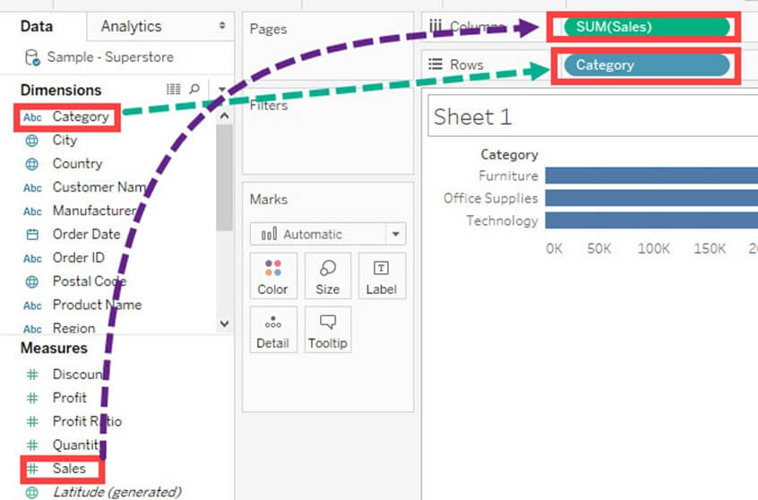It creates a bar chart by default. Category Present in the visual is sorted based on data source order by default. We can change the sort order by following the below procedure.

**Step 2)**

1. Right click on Category.
2. Select 'Sort' option.

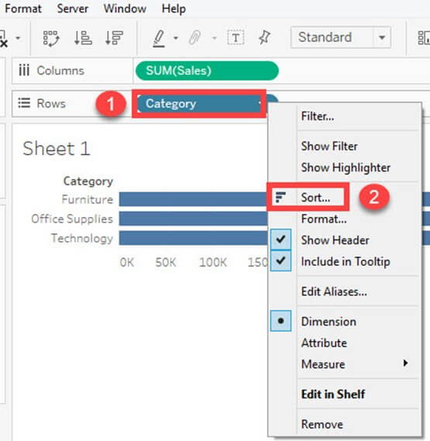It opens the Sort window. The options present inside the sort window is explained as follows. 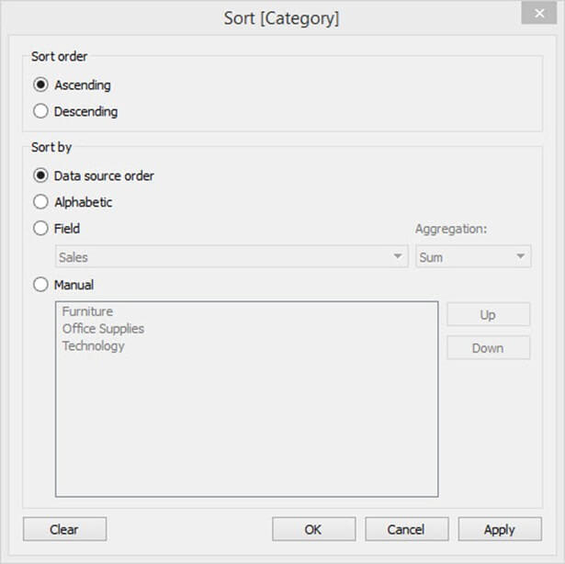**Sort Order:**

* Ascending: It sorts the order of selected dimension in ascending order.
* Descending: It sorts the order of selected dimension in descending order.

**Sort by:**

The field can be sorted by different types of methods. It is explained as follows.

|  |  |
| --- | --- |
| **Data Source order** | It sorts the field based on data source order. |
| **Alphabetic** | It sorts the field based on the alphabetic order. |
| **Field** | It sorts the field based on other dimension or measure values. |
| **Manual** | The user can manually sort the data using this option. |

In this example, the category is sorted based on another field namely 'Sales.'

**Step 1:**In this window,

1. Click on 'Field' radio button.
2. Select the field on which the category is to be filtered.
3. Select the aggregation type.
4. Click on OK.

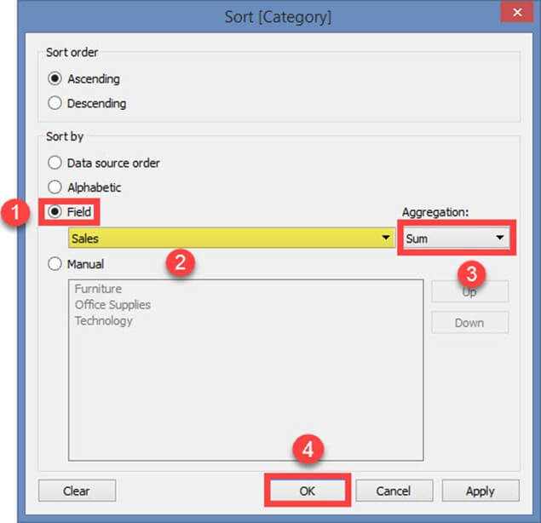The above example filters the category field based on the sum of sales in ascending order.

It sorts the data as shown in the figure.

## https://www.guru99.com/images/tableau/060818_0634_TableauSort5.jpgCreate Groups:

Group is used to combine members present in a field. For example, aggregated values of 'Furniture' and 'Office Supplies' can be obtained by using group. Once the group is built, aggregated value of 'Furniture' and 'Office Supplies' can be shown in the visuals. The procedure to build group is given as follows.

**Step 1)**

1. Right-click on the dimension 'Category'.
2. Click on 'Create' option.
3. Select 'Group' option.

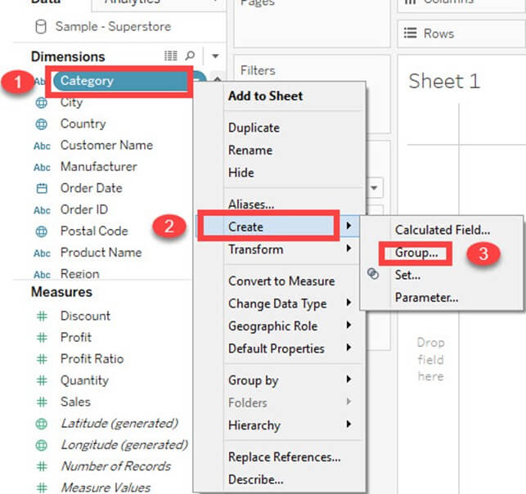**Step 2)** It opens the 'Create group' window.

1. Type the name of the group.
2. Select the members to be grouped.
3. Click on 'Group 'button.

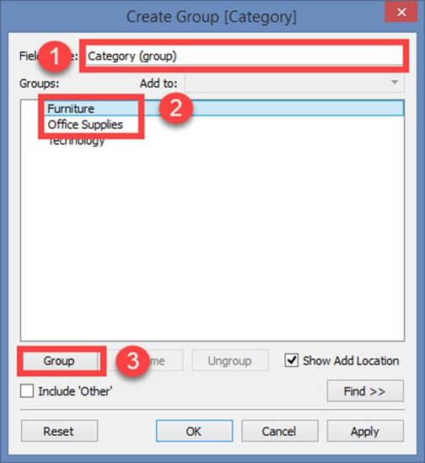**Step 3)** In Edit Group Window,

1. It creates a group of 'Furniture' and 'Office supplies'.

2. Click on Ok to create the group.

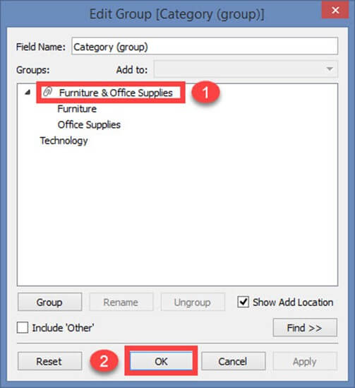It created a group in the name of Category (Group) and added in the dimension list. This can be used for visualizing the group of members present in a field.

The following image explains the functionality. The sum of sales is visualized for both furniture and office supplies.

## https://www.guru99.com/images/tableau/060818_0634_TableauSort9.jpgCreate Hierarchy:

Hierarchies can be building in Tableau to visualize the data in granular level. It can be created in tableau by following the given steps.

**Step 1)** Go to a worksheet.

1. Select a dimension to create a hierarchy. Right-click on the dimension.
2. Select 'Hierarchy' option.
3. Click on 'Create hierarchy' option.

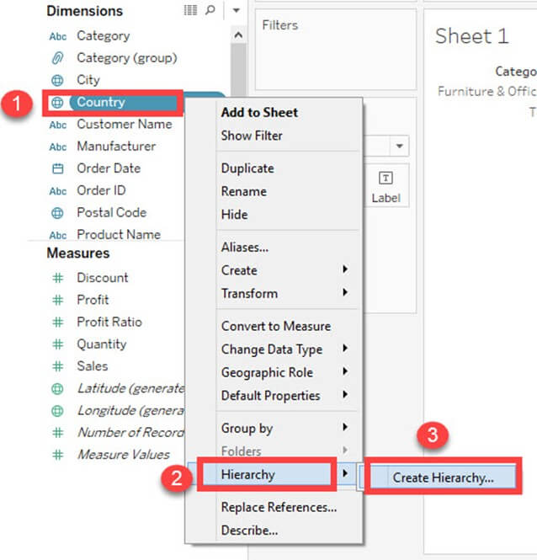**Step 2)** It opens the 'Create Hierarchy' Window.

1. Enter a name for hierarchy.
2. Click on OK.

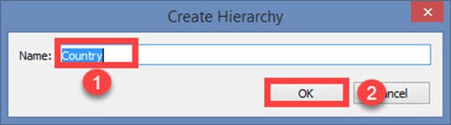

It creates a Hierarchy as shown in the image.

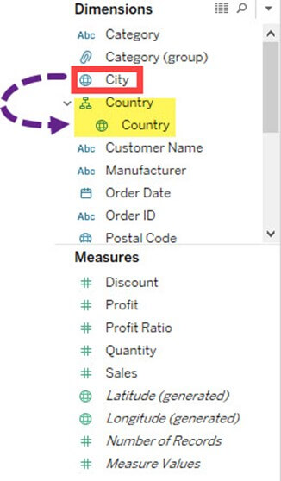

## Build Sets:

Sets create a set of members out of the field present in a data set. It acts as a separated field or dimension. The procedure to build sets is given as follows.

**Step 1)** Go to a Worksheet.

1. Right-click on a dimension.
2. Select 'Create' option.
3. Click on 'Set' option.

You can add another field to the box and create the hierarchy. In this example, the city is added into a country hierarchy.

## https://www.guru99.com/images/tableau/060818_0634_TableauSort13.jpg

## Build Sets:

Sets create a set of members out of the field present in a data set. It acts as a separated field or dimension. The procedure to build sets is given as follows.

**Step 1)** Go to a Worksheet.

1. Right-click on a dimension.
2. Select 'Create' option.

Click on 'Set' option. 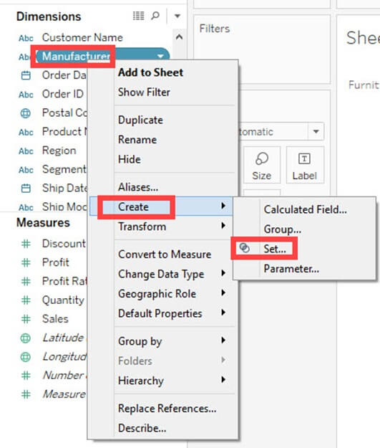

**Step 2)** It opens 'Create Set' Window.

1. Name the set to be created.
2. Select the members needs to be added in the set.
3. Click on OK.

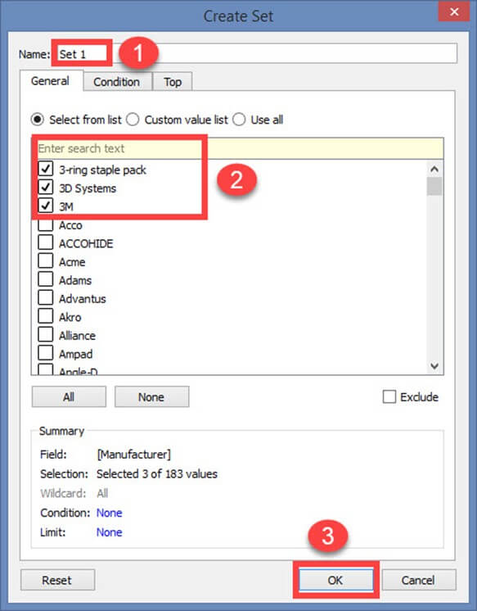

This creates a set of the given name.

**Summary:**

* Users can sort the fields present in the data set.
* Groups can be building to group the members present in a dimension.
* Users can build hierarchy to show the granularity level present in the dataset.
* Sets can be created to select or exclude one or more members from a field. A set can be added as a separate dimension in Tableau.

# 8.Tableau Charts & Graphs Tutorial: Types & Examples

Tableau can create interactive visualizations customized for the target audience. In this tutorial, you will learn about the measures, chart types and its features.

In this tutorial, 'Sample-Superstore.csv' is used for the demonstration. You can connect to the data source and follow the steps given in the tutorial.

* [Measure names and Measure values](https://www.guru99.com/tableau-charts-graphs-tutorial.html#1)
* [Generated Fields](https://www.guru99.com/tableau-charts-graphs-tutorial.html#2)
* [Understand how and when to build different types of Visuals](https://www.guru99.com/tableau-charts-graphs-tutorial.html#3)
* [Pareto Chart](https://www.guru99.com/tableau-charts-graphs-tutorial.html#4)
* [Bullet Chart](https://www.guru99.com/tableau-charts-graphs-tutorial.html#5)
* [Bar Chart](https://www.guru99.com/tableau-charts-graphs-tutorial.html#6)
* [Line chart](https://www.guru99.com/tableau-charts-graphs-tutorial.html#7)
* [Text Tables](https://www.guru99.com/tableau-charts-graphs-tutorial.html#8)
* [Heat Map](https://www.guru99.com/tableau-charts-graphs-tutorial.html#9)
* [Waterfall Chart](https://www.guru99.com/tableau-charts-graphs-tutorial.html#10)
* [Gantt chart](https://www.guru99.com/tableau-charts-graphs-tutorial.html#11)
* [Pie Chart](https://www.guru99.com/tableau-charts-graphs-tutorial.html#12)
* [Scatter Plot](https://www.guru99.com/tableau-charts-graphs-tutorial.html#13)
* [Area Chart](https://www.guru99.com/tableau-charts-graphs-tutorial.html#14)
* [Dual Axis Chart](https://www.guru99.com/tableau-charts-graphs-tutorial.html#15)
* [Bubble Chart](https://www.guru99.com/tableau-charts-graphs-tutorial.html#16)
* [Histogram](https://www.guru99.com/tableau-charts-graphs-tutorial.html#17)

## Measure names and Measure values:

Measure names and Measure values are the two fields created in Tableau by default. These fields are created when a data set is imported into Tableau. You can go to a Data pane of the worksheet and view the fields as shown in the figure.

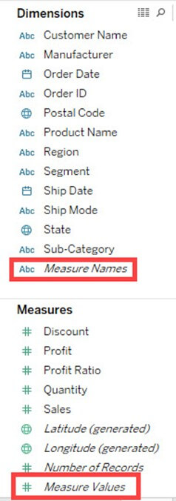**Measure Names:**

A measure name consists of all the names of the measure present in a data set. It always presents at the end of dimension list. It consists of discrete values of all measure names.

**Measure Values:**

All the measure values present in a data set are kept together in the field called measure values. It always presents at the end of measures list. It consists of continuous values of all measures.

**Use cases of Measure Names and Measure Values:**

**Case 1:**

Measure names and Measure values can be used to see the aggregation of all measure present in a data set. These fields can be shown as different types of visualization in Tableau.

**Steps:**

1. Drag 'Measure Names' into Columns.
2. Drag 'Measure Values' into Rows.

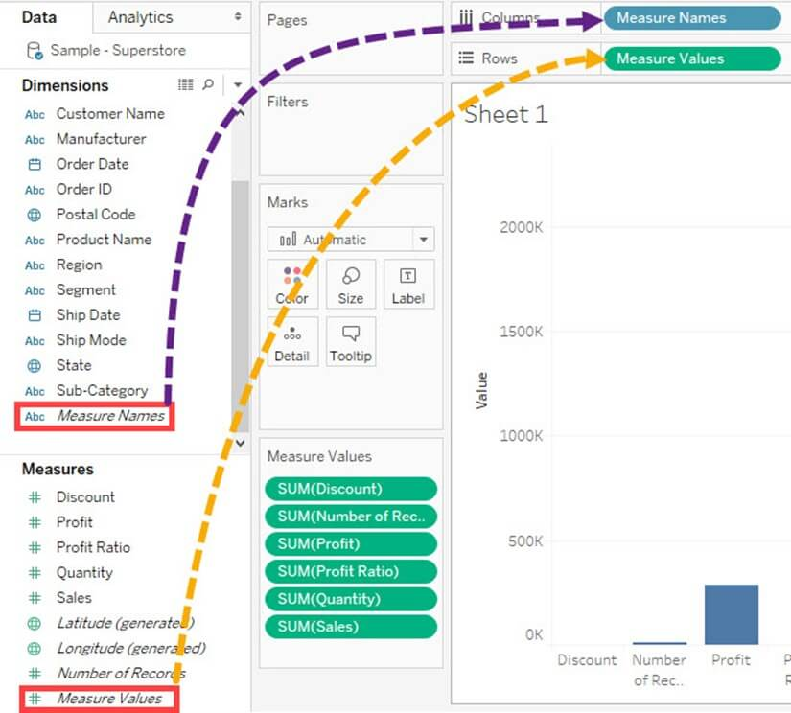It creates a visual for all measures present in the data set. By default, Tableau creates a **bar chart** showing all the measure names and their values.

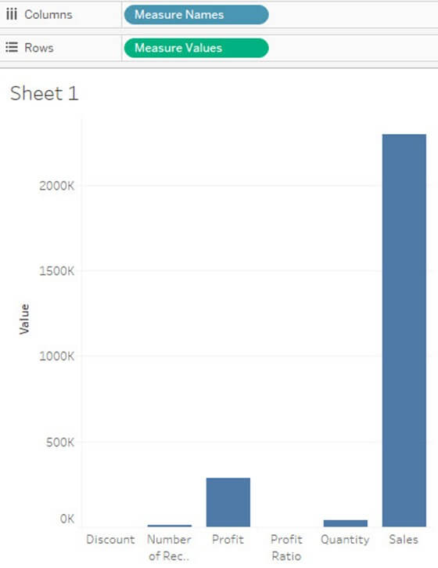

**Case 2:**

Any measures can be removed from the visual by removing the measure from mark card. It can be removed by

1. Right-click on a measure name.
2. Click on 'Remove' option.

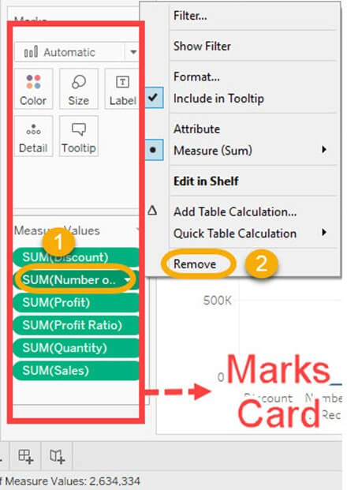

It removes the measure from the visualization.

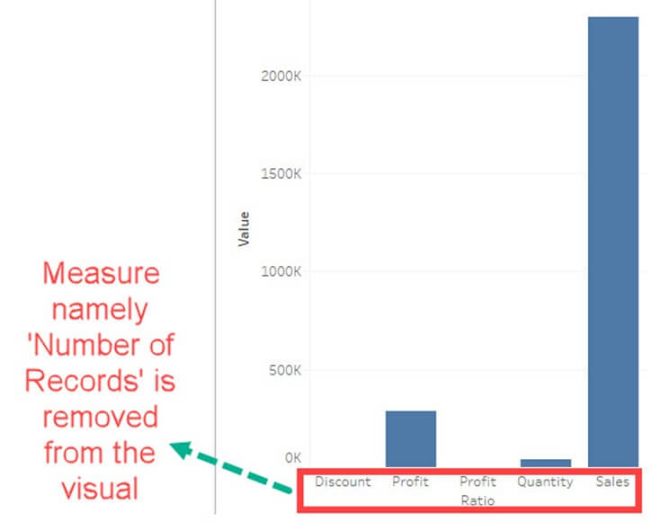

**Case 3:**

Alias name can be created for measure names. It can be shown in the visualization for better identification.

**Step 1)**Use the same steps given in case 2 and follow the below steps.

1. Right click on measure name present in Columns.
2. Select the 'Edit Alias' option in the list.

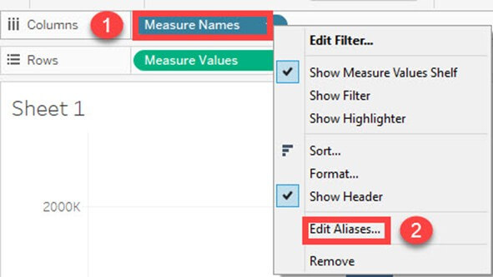

**Step 2)**It opens 'Edit Aliases' Window.

1. Edit the alias name for the member. In this example, 'Volume Sales' is given as alias name for 'Quantity'.
2. Click on OK.

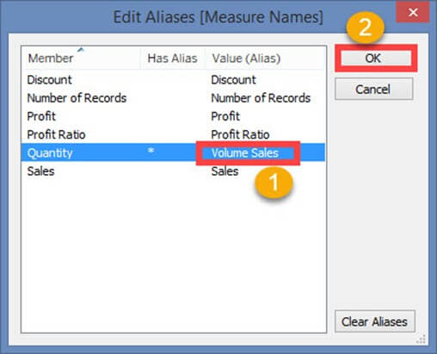

You can see the name change in Visualization.

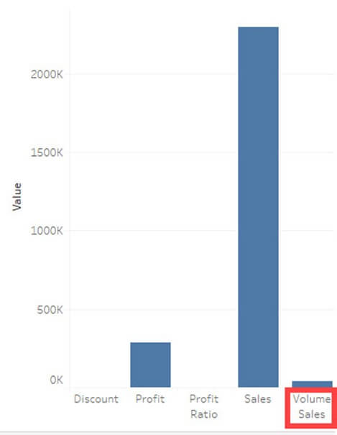

**ase 4:**

If you want to analyze multiple measures in a single visual, it can be done by using measure names and measure values.

In this example, we will see the trend of measures namely sales, profit and quantity over the years.

**Step 1)**

1. Drag measure values into the filter box.
2. It opens a filter window.
3. Check out all the measures except Profit, Quantity, and Sales.
4. Click on OK button.

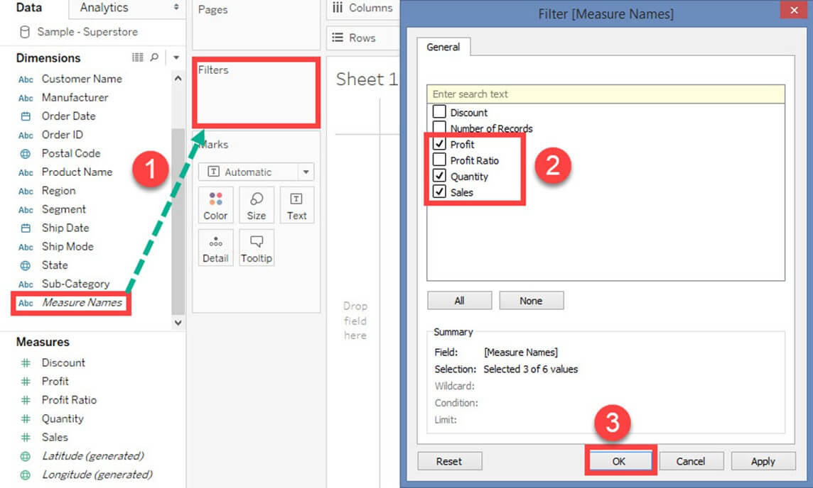

It adds the measure name filter in the filter box.

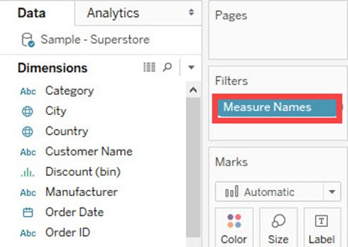

**For example:**The above filter condition shows the visual as follows:

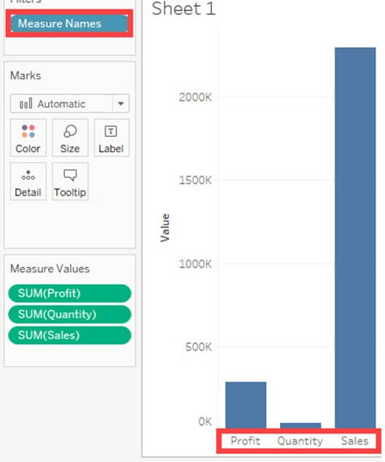

It creates a filter on selected measures in the worksheet.

**Step 2)**

1. Drag 'Order Date' into Columns.
2. Drag 'Measure Values' into Rows.

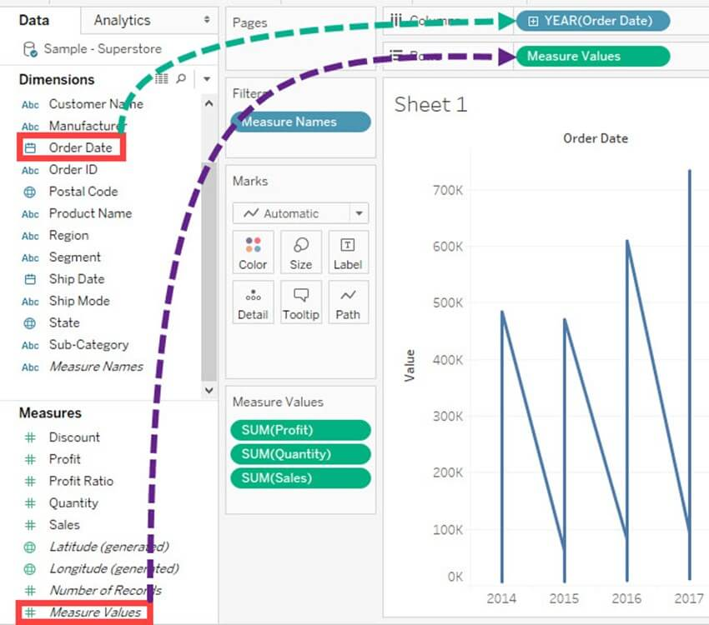

**Step 3)**

1. Drag Measure Names into 'Color' option present in the marks card.
2. It creates color of the visual based on the measure name. It also specifies different color to different measure names present in the visual.
3. A line chart is generated for multiple measures over years as shown in the figure.

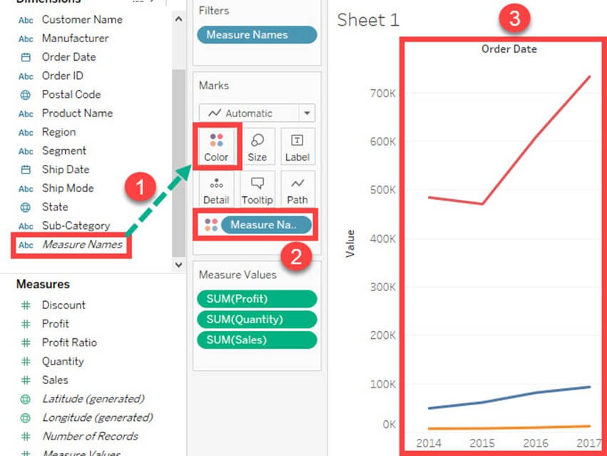

## Generated Fields:

Tableau generates some fields which can be visible in the data pane. These fields are generated in addition to the fields present in the data set. The generated fields are given as follows.

* Measure Names
* Measure Values
* Number of Records
* Longitude
* Latitude

Measure Names and Measure Values are already explained in the article.

**Number of Records:**

Number of records shows the count of records present in the data set. It is an auto-generated field in Tableau which assigns a value '1' for each record present in the data set. It can be used to verify the count of records when joining multiple tables. The procedure to check the number of records present in a dataset is given as follows.

**Step 1)**Go to a Worksheet

1. Drag 'Number of Records' present in measure pane into Rows.
2. It creates a bar chart by default. Hover over the bar to see the number of records present in the data set.

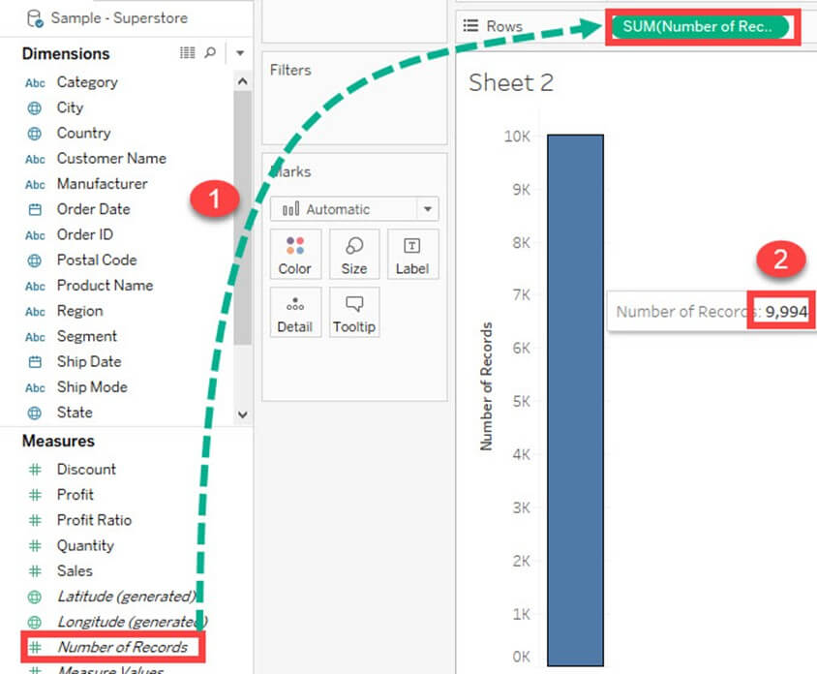

**Longitude and Latitude:**

Longitude and Latitude (generated) fields are associated with the geographical detail present in the data. Dataset should consist of geographical details like City, Country or State. The longitude and latitude values are auto-generated in Tableau. These fields can be used to build maps in Tableau. You can create geographical maps using Longitude and Latitude is given as follows.

**Step 1)** Drag Longitude (generated) into columns and Latitude (generated) into Rows.

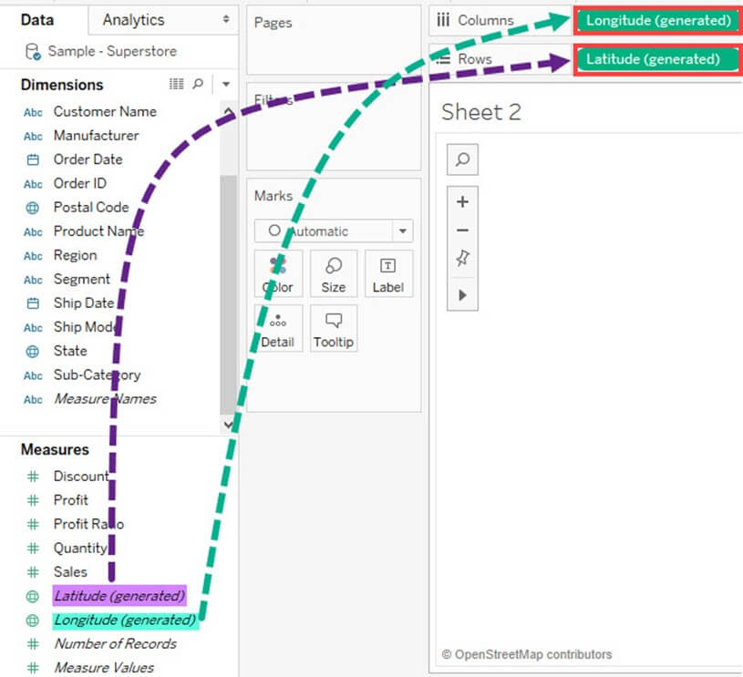

**Step 2)** Drag 'State' from Dimension list into 'Detail' present in Marks Card.

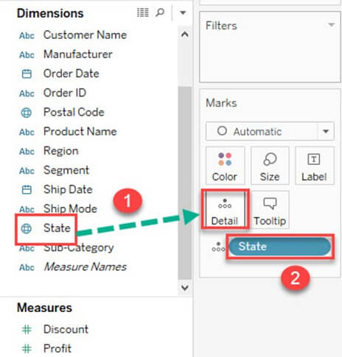

This creates a geo-mapping visual as shown below.

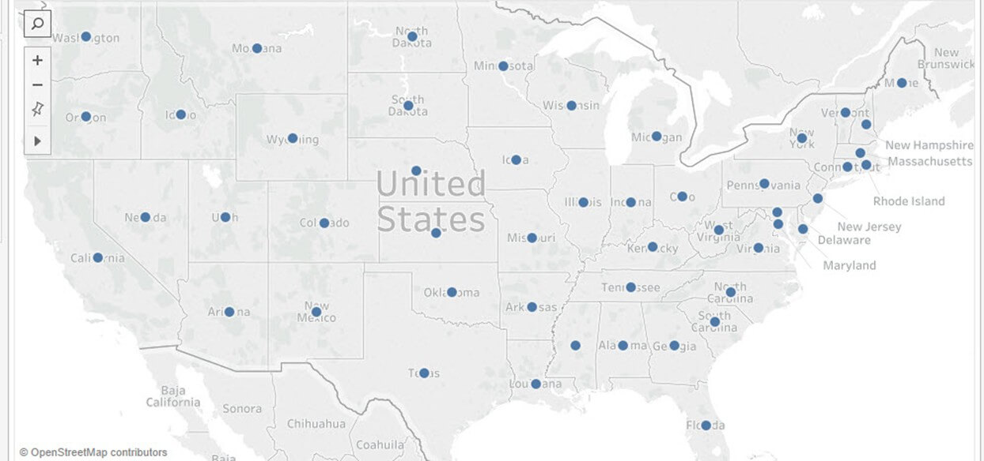

## Understand how and when to build different types of Visuals:

Tableau can create interactive visuals for easy data interpretation. You can create various types of graphs in Tableau based on the purpose. The different charts that can be created using Tableau and their purpose are given as follows.

### Pareto Chart:

A Pareto chart consists of both bar and line graph. The same measure is used to create the graphs but the measure values are manipulated differently. The purpose of using Pareto Chart in Tableau is to identify the contribution of members present in a field. For example, Profit contributed by different subcategory of products in a retail store can be analyzed using Pareto Chart. It can show the top members and their contribution. The procedure to create a Pareto Chart is given as follows.

**Step 1)**Go to a new Worksheet

1. Drag 'Sub-Category' into Columns.
2. Drag 'Profit' into Rows.

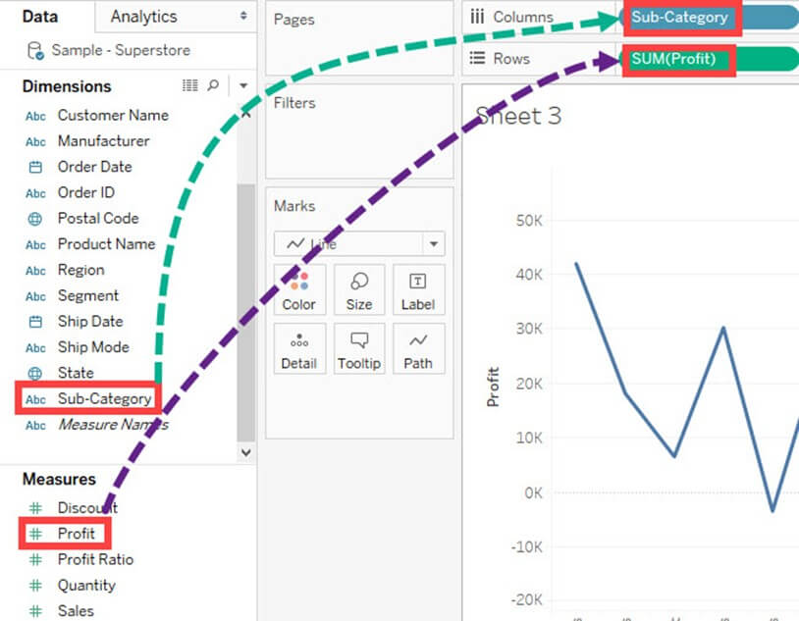

**Step 2)**

1. Right click on 'Sub-Category'.
2. Select 'Sort' option from the list.

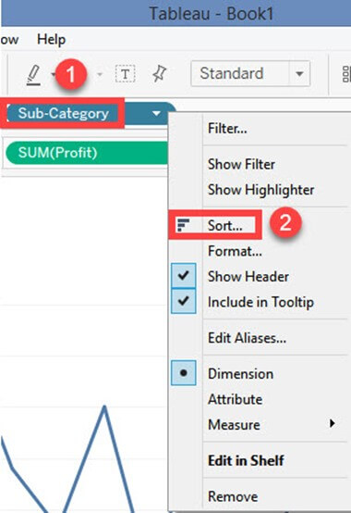

**Step 3)**It opens a Sort Window.

1. Click on 'Descending' in Sort order.
2. Select 'Field' in 'Sort by" section. Select the field as Profit and choose 'Sum' as aggregation.
3. Click on OK.

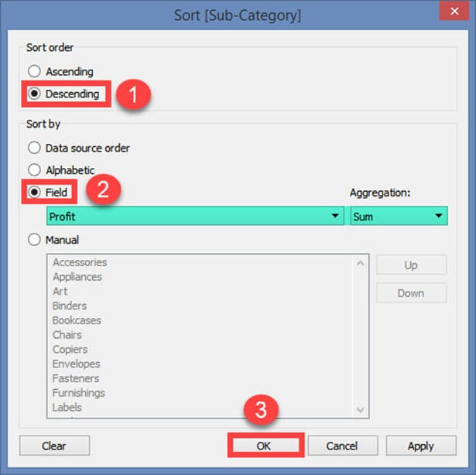

**Step 4)**

1. Drag 'Profit' again into Rows.
2. Right-click on the newly added 'Profit' and Select 'Dual axis' option.

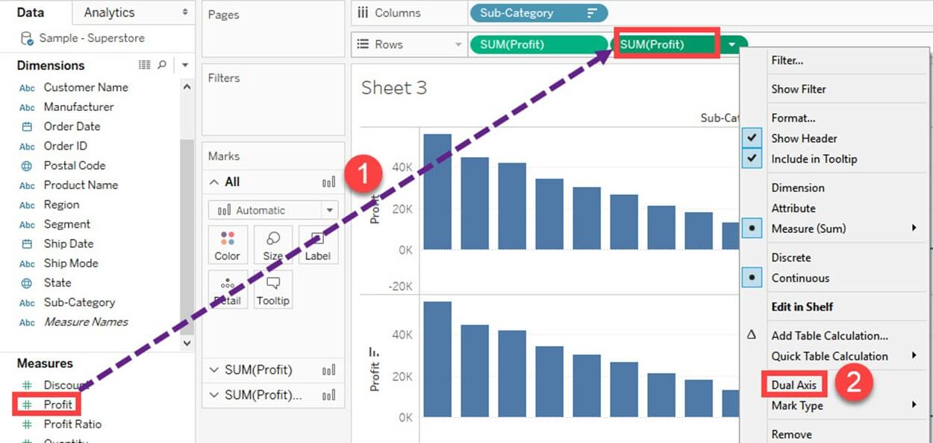

It merges the x-axis of both measures and converts the visualization as given below.

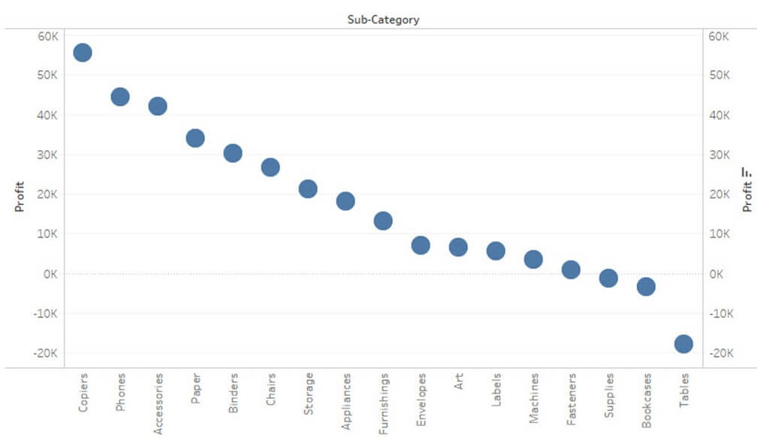

**Step 5)**Go to Marks Card

1. Select 'SUM(Profit)' for the marks card list.
2. Click on the drop-down button as shown in the image.
3. Select 'Bar' as chart type.

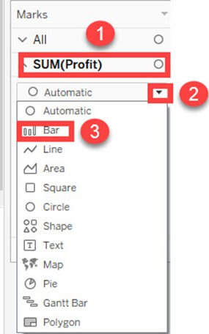

**Step 6)**

1. Select 'SUM(Profit)(2)' from the marks card list.
2. Select the drop-down button as given in the image.
3. Click on 'Line' from the list.

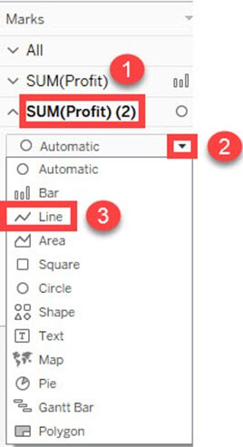

**Step 7)**

1. Select 'SUM(Profit)' on the right side of rows as shown in the image.
2. Right click on it and select 'Add Table Calculation' from the list.

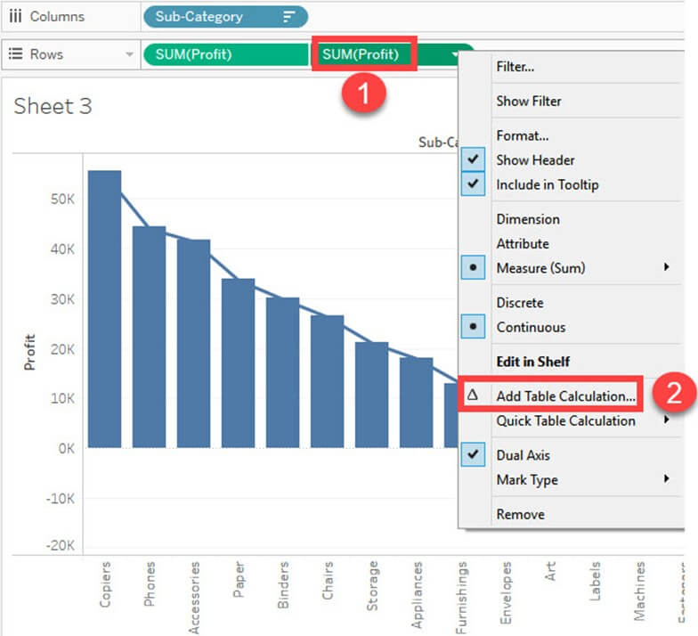

**Step 8)**It opens the Primary Calculation Type window.

1. Select 'Running Total' from the drop-down.
2. Select 'Sum' as aggregation from the drop-down.
3. Click on Compute Using 'Table (across)'.
4. Check in the 'Add Secondary Calculation' box.
5. It expands the window for 'Secondary Calculation Type'. Select 'Percent of Total' from the dropdown list.
6. Select on Compute Using 'Table (across)'
7. Now close the Window by clicking on close icon as shown in the image.

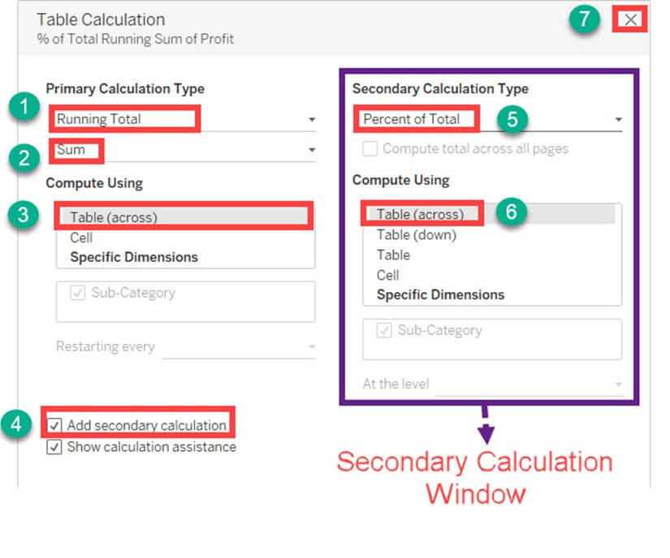

**Step 9)**

1. Go to the last marks card namely 'SUM (Profit)'.
2. Click on color icon present in the marks card.

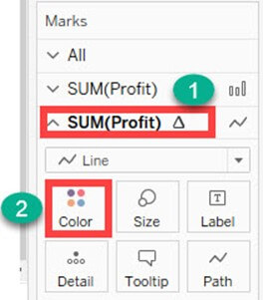

**Step 10)**Select any color of your choice. This changes the color of line present in the graph.

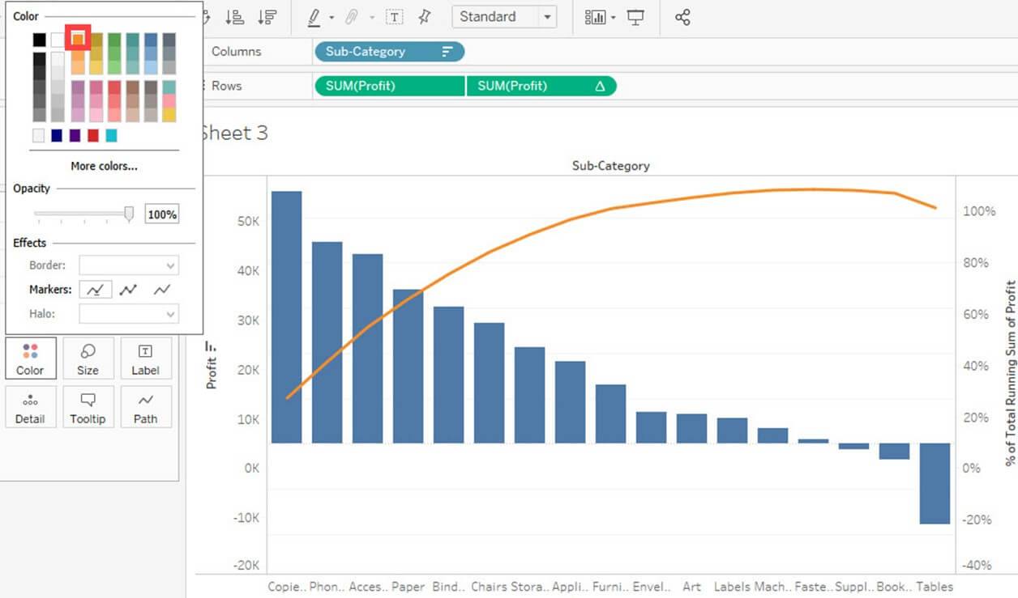

This is the procedure to create Pareto Chart in Tableau.

### Bullet Chart:

A bullet chart can be used as a gauge or indicator to show the performance of measures. Two measures can be compared to each other using the bullet graph. For example, if we are having estimated profit and actual profit we can compare both of them using bullet chart. The procedure to create bullet chart is given as follows.

**Step 1)**Go to a new Worksheet.

1. Click on 'Analysis' present in the Menu bar.
2. Select 'Create Calculated Field' from the list.

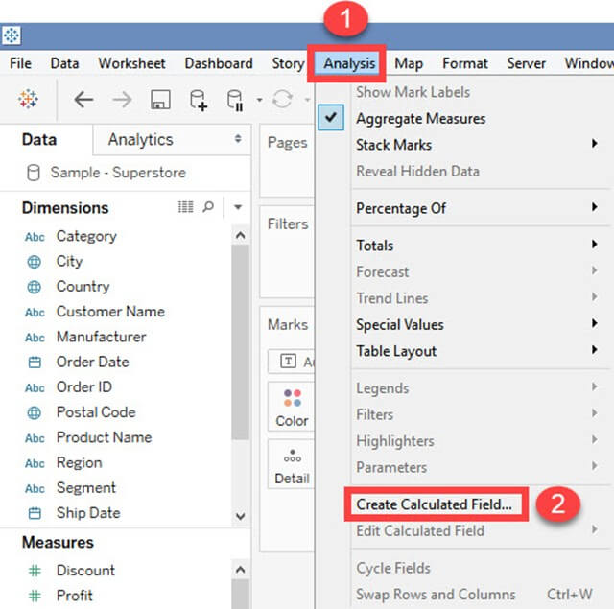

**Step 2)** It opens Calculated Field Window.

1. Enter a name for the calculated field. In this example, it is named as 'Estimated Profit'.
2. Type the estimated value of the measure. In this example, Profit is taken as the measure. So the calculated field is created for estimated profit.
3. Click on OK.

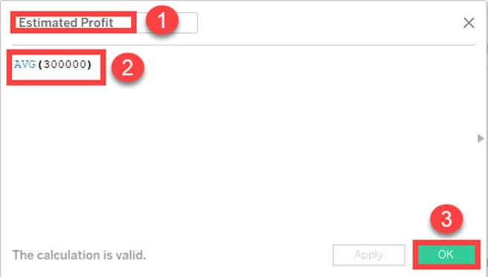

**Step 3)**Go to measures in Data pane. Hold the control key in keyboard and select 'Estimated Profit' and 'Profit'.

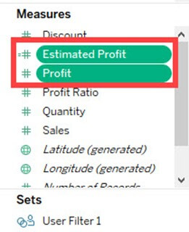

**Step 4)**

1. Click on 'Show me' button present in the top right corner of the worksheet.
2. Select bullet graph icon as shown in the image.

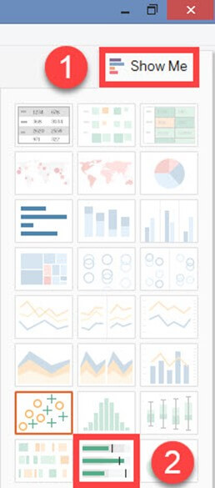

It creates a bullet graph as shown below.



### Bar Chart:

A bar chart can compare the data across different categories. The height of the bars represents the measured value of each category. It can be represented as vertical and horizontal type bar charts. The procedure to create bar chart is given as follows.

**Step)**Go to a new worksheet.

1. Drag 'Category' into Column.
2. Drag 'Profit' into Rows.
3. It creates a bar chart by default.

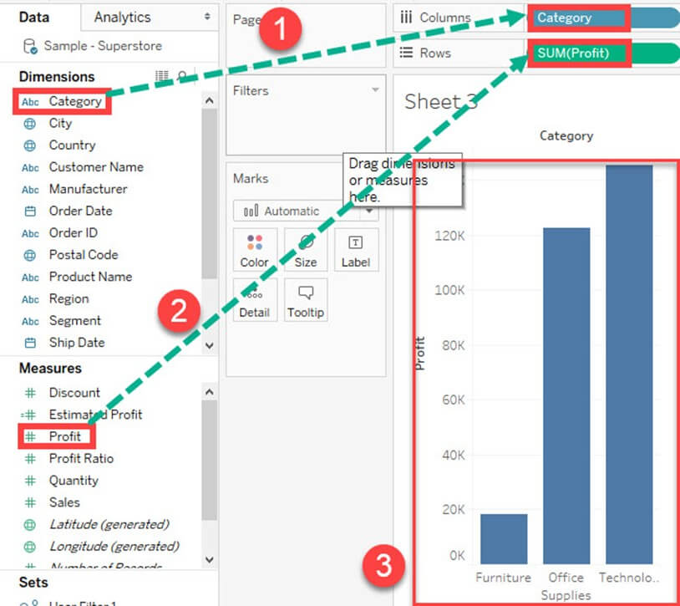

### Line chart:

A Line Chart should be used to compare the data over the different periods. A line chart is created by the series of dots. These dots represent the measured value in each period. The procedure to create line graph is shown below.

**Step)**Go to a new Worksheet.

1. Drag 'Order Date' into Columns.
2. Drag 'Sales' into Rows.
3. It creates a line chart by default.

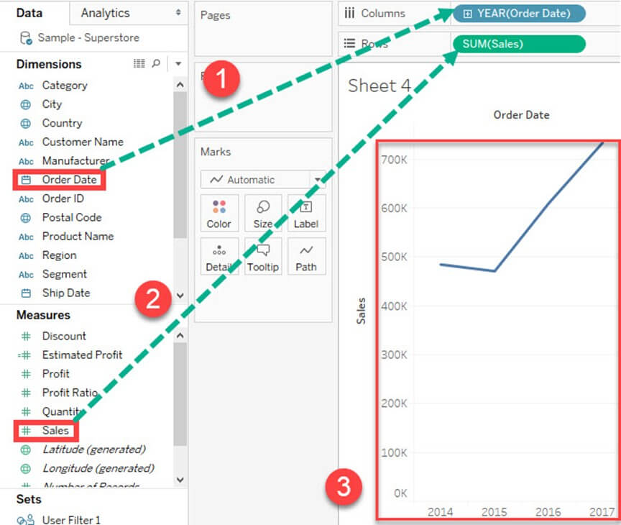

### Text Tables:

Text tables are used to show the exact value of measures across the different dimension. A text table is also called as a **Pivot Table**. It groups the dimensions and measures by default. The procedure to design a text table is given as follows.

**Step)**Go to a new Worksheet.

1. Drag 'Sub-Category' into Rows.
2. Drag 'Profit' into text box present in the marks card.
3. It creates a text table by default.

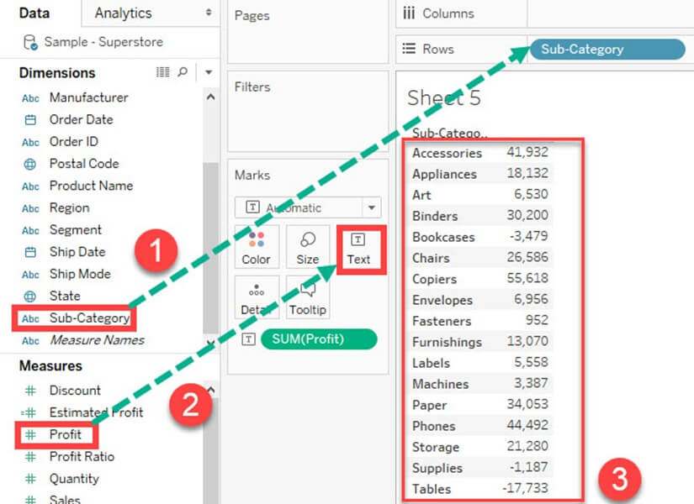

### Heat Map:

A heat map can visualize the data in the form of size as well as color on different measures. Two different measures can be visualized simultaneously using heat map. One measure can be assigned to size whereas another measure can be assigned to the color of the heat map. The procedure to create heat map is given as follows:

**Step 1)**Go to a new Worksheet.

1. Hold the control key in keyboard and select 'Sub-Category' and 'Sales' from the data pane.

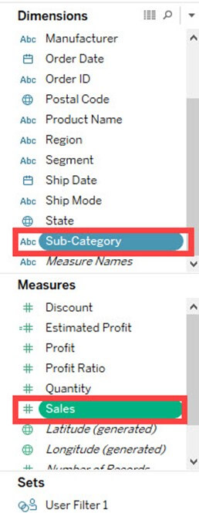

**Step 2)**

1. Click on the 'Show me' button present in the top right corner of the worksheet.
2. Select the 'Heat Map' icon as shown in the image.

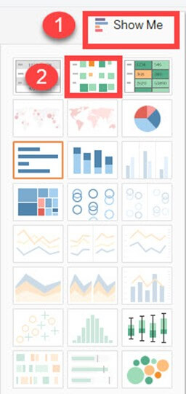

**Step 3)**Drag 'Profit' into the Color box.

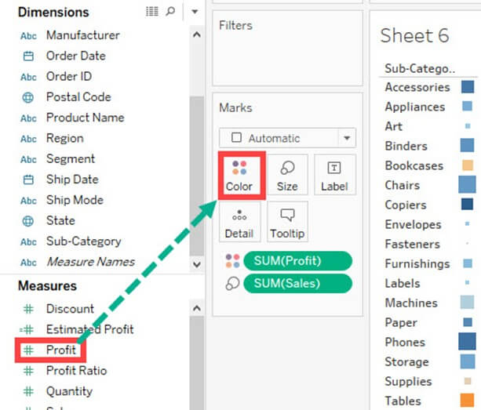

**Step 4)**

1. Drag 'Region' into Columns.
2. This will create a Heat map. It can be used to visualize Sales and Profit across different dimension.

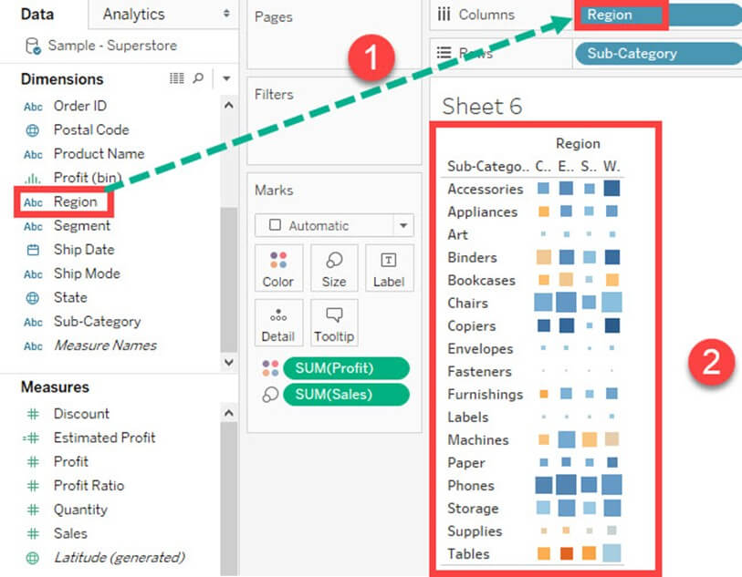

### Waterfall Chart:

Waterfall Chart can visualize the cumulative effect of a measure over dimension. It can show the contribution of growth or decline by each member in a dimension. For example, you can see the contribution of profit by each sub-category using a waterfall chart. The waterfall chart can be designed in Tableau by following the given procedures.

**Step 1)**Go to a new Worksheet.

1. Drag Sub-Category into Columns
2. Drag Profit into Rows.

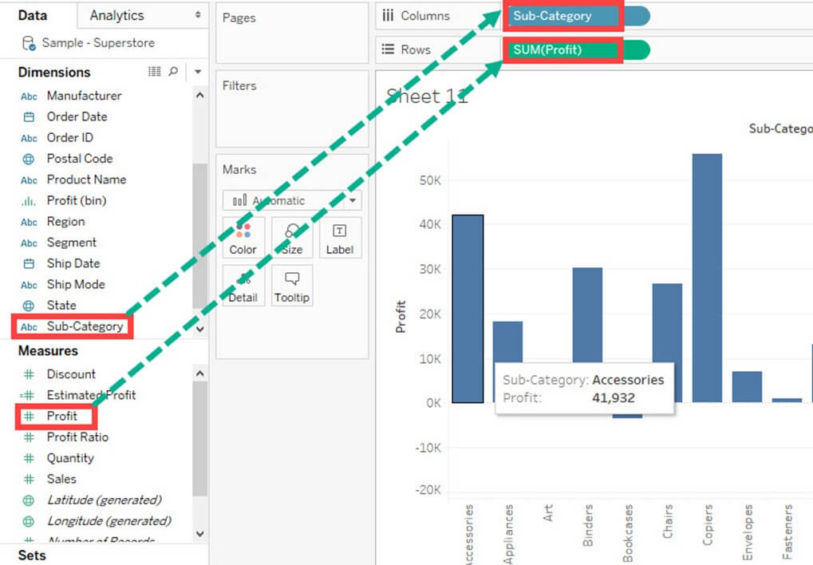

**Step 2)**

1. Right click on 'Profit' present in Measures Pane.
2. Choose 'Create' from the list.
3. Select the 'Calculated Field' Option.

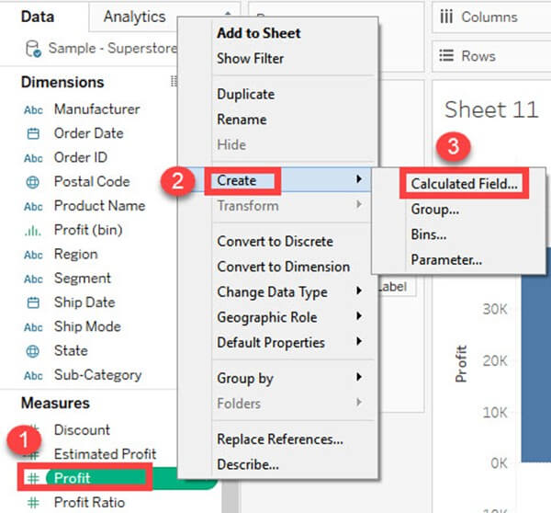

**Step 3)**It opens 'Calculated Field' Window.

1. Enter the name of the Calculated field as '-Profit.'
2. Write the formula as shown in the image.
3. Click on OK.

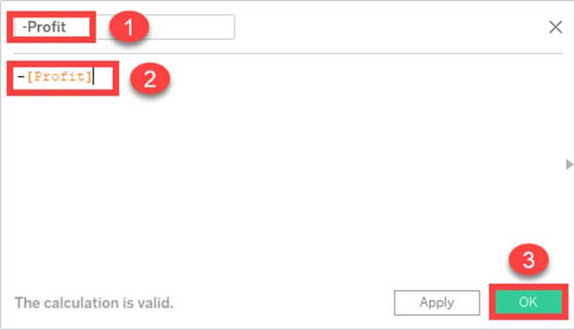

**Step 4)**Drag the newly created calculated field '-Profit' into size option present in the marks card.

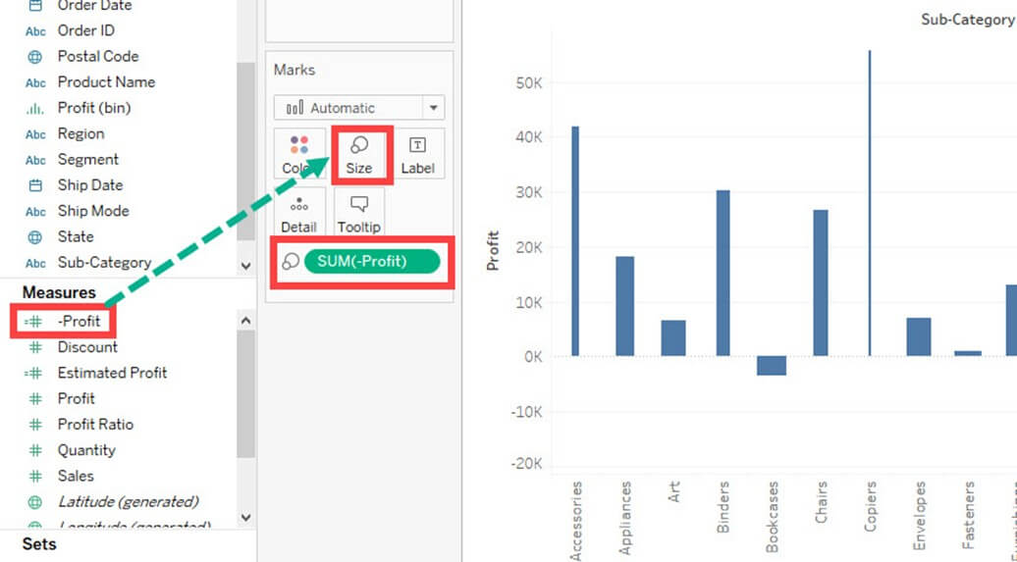

**Step 5)**

1. Right, Click on 'SUM (Profit)' present in the Rows.
2. Select 'Quick Table Calculation' from the list.
3. Click on 'Running Total' option.

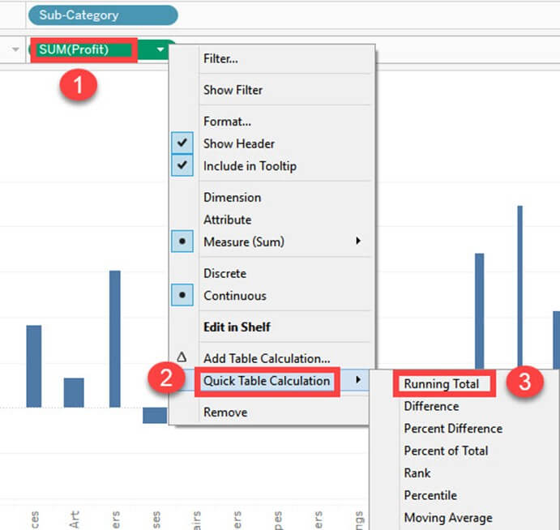

**Step 6)**

1. Click on the drop-down option present on the marks card.
2. Select 'Gantt Chart' from the list.

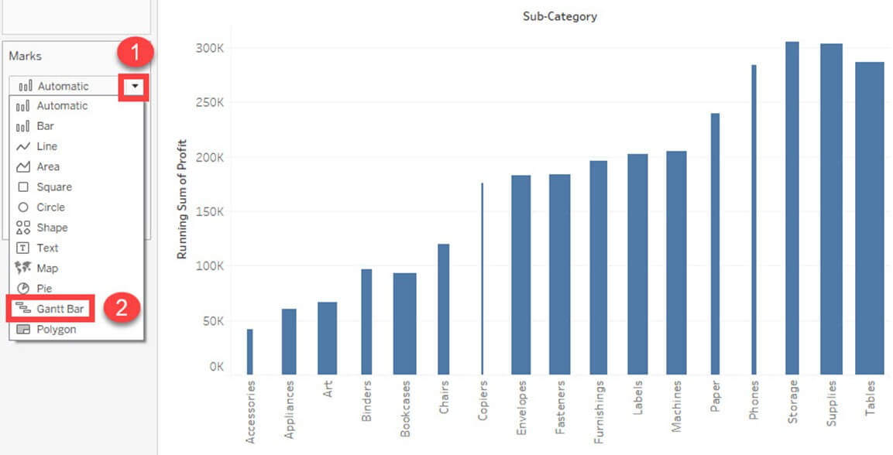

This creates a waterfall chart as shown below.

### https://www.guru99.com/images/tableau/060818_0650_TableauChar47.jpgGantt chart:

A Gantt chart can show the comparison of data between categories. It can be used to identify the time taken for each process. In the below example, time taken for shipment by each type of ship mode is given. The procedure to create Gantt chart is given as follows.

**Step 1)**Go to a new Worksheet.

1. Click on the drop down button in Marks Card.
2. Select 'Gantt Bar' from the list.

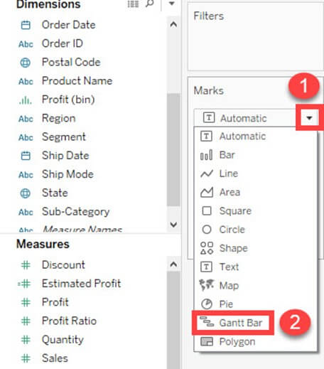

**Step 2)**

1. Drag 'Order Date' into Columns.
2. Right Click on the Order date and select the 'Day' as shown in the image.

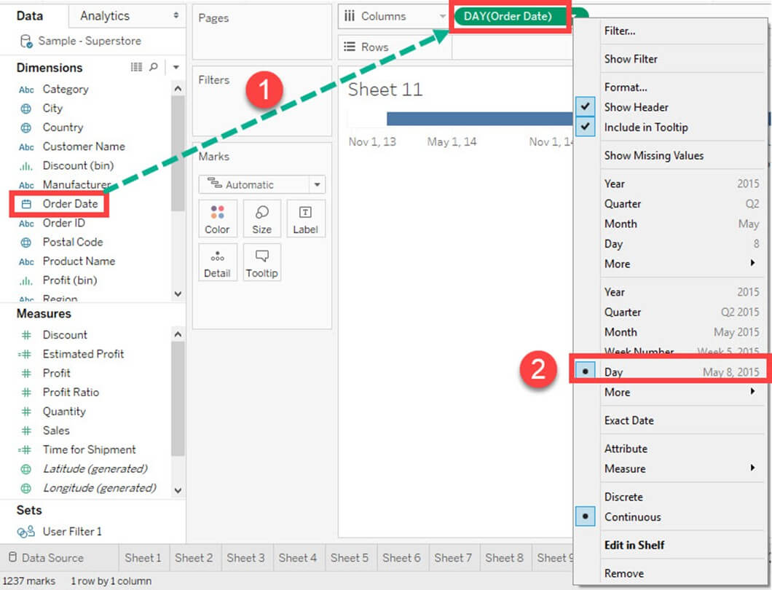

**Step 3)**

1. Click on 'Analysis' Present in Menu bar.
2. Select 'Create Calculated Field' present in the list.

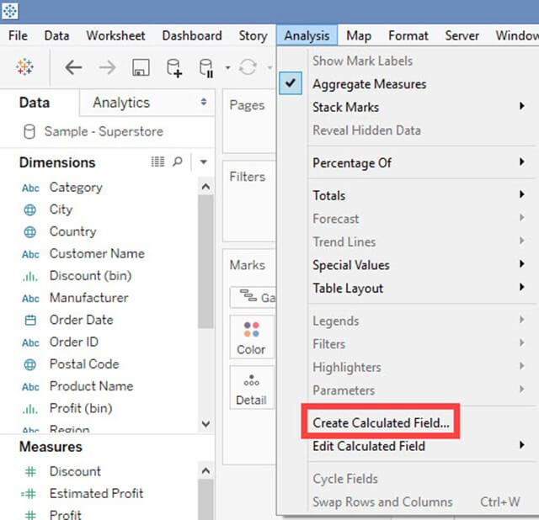

**Step 4)**

1. Enter the name of calculated field as 'Time for Shipment'
2. Type the formula as shown in the image to create difference between order date and ship date.
3. Click on OK.

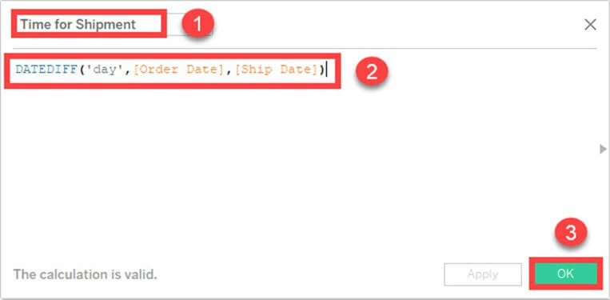

**Step 5)**

1. Drag 'Ship Mode' into Rows.
2. Drag 'Time for Shipment' into size icon present in the marks card.

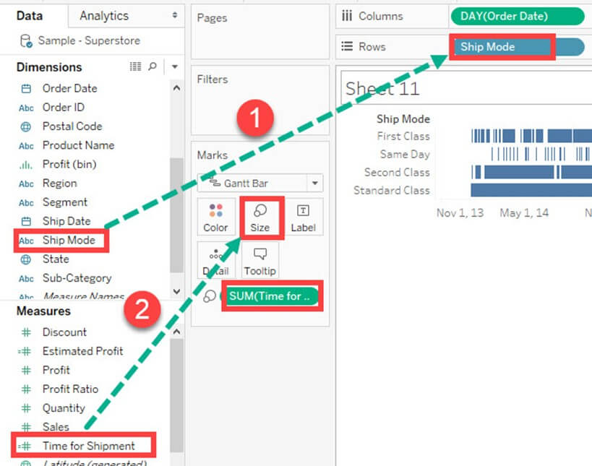**Step 6)**This creates a Gantt chart. It shows the time taken for each shipment across different ship mode.

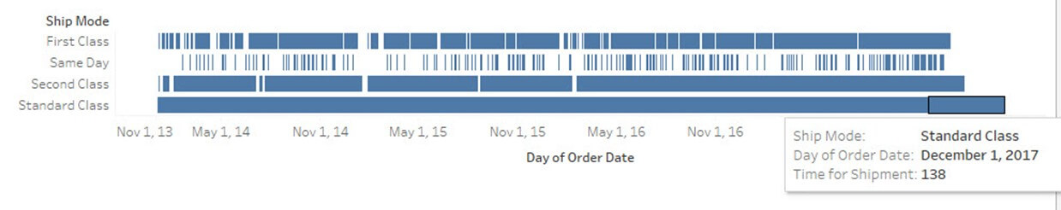

### Pie Chart:

A pie chart can show the segment-wise data. It can show the contribution of measure over different members in a dimension. The angle of pie determines the measured value. Different colors can be assigned to pie to represent the members in a dimension.

**Step 1)**Go to a new Worksheet

1. Select Segment and Sales from data pane.

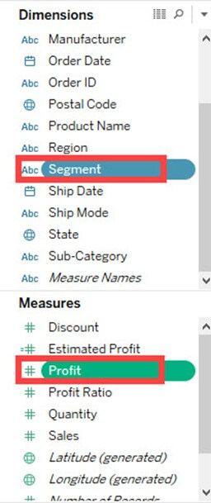**Step 2)**

1. Click on 'Show Me' button present in the top right corner of the worksheet.
2. Select 'Pie Chart' from the list.

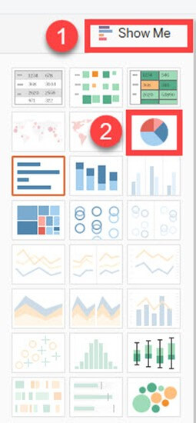

It creates a Pie Chart as shown below.

### https://www.guru99.com/images/tableau/060818_0650_TableauChar56.jpgScatter Plot:

The relationship between two measures can be visualized using scatter plot. A scatter plot is designed by adding measures in both x and y-axis. This can show the trend or relationship between the measures selected. A scatter plot can be designed by following the below procedure.

**Step 1)**Go to a new Worksheet.

1. Drag 'Discount' into Columns.
2. Drag 'Sales' into Rows.

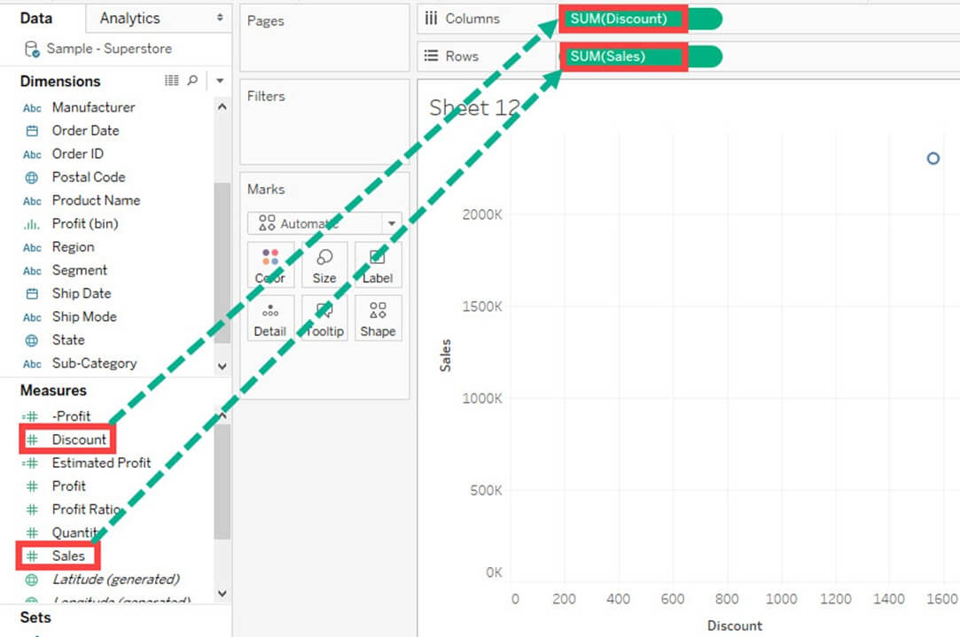

This creates a scatter plot by default.

**Step 2)**

1. Drag 'Sub-Category' into Color icon present in the Marks card.
2. It creates a scatter plot showing the relationship between discount and sales for each sub-category.

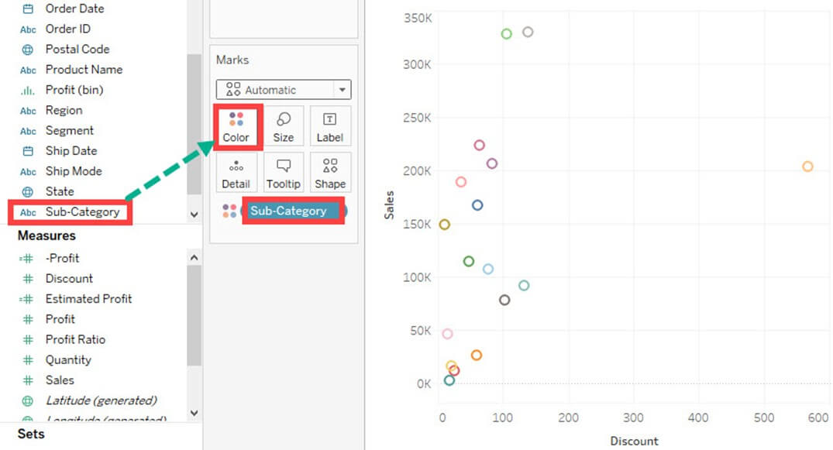

### Area Chart:

Area chart can represent any quantitative (measure) data over different period of time. It is basically a line graph where the area between line and axis is generally filled with color. The procedure to create area chart is given below.

**Step 1)**Go to a new Worksheet.

1. Hold the control key in keyboard and select 'Order Date' and 'Quantity'.

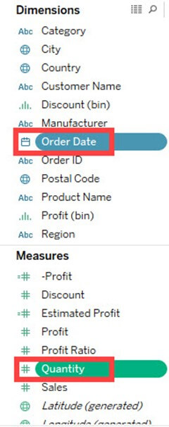

**Step 2)**

1. Click on 'Show Me' option present at the top right corner of the worksheet.
2. Select the Area chart icon as shown in the figure.

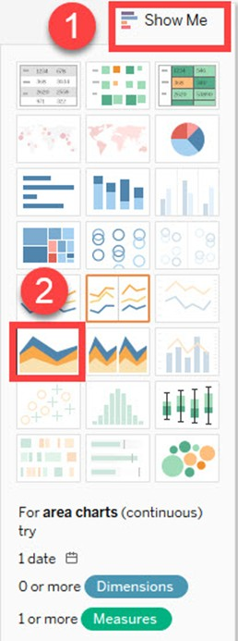

**Step 3)**

1. Drag 'Region' from dimension pane and add it in color icon of Marks card.
2. This creates an area chart as shown in the image.

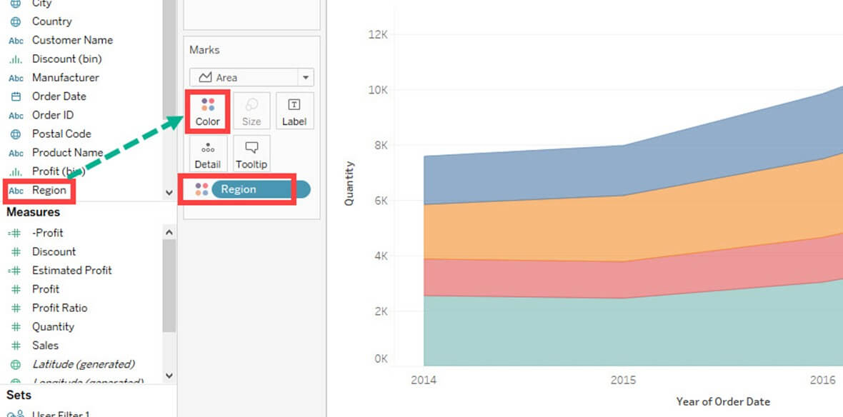

### Dual Axis Chart:

Dual axis chart can be used to visualize two different measures in two different chart types. A date column and two measures are necessary to build a dual axis chart. The different scales used in the graph helps the user to understand both measures. The procedure to create dual axis chart is shown below.

**Step 1)**Go to a new Worksheet.

1. Hold the control key and select 'Order Date', 'Sales' and 'Quantity'.

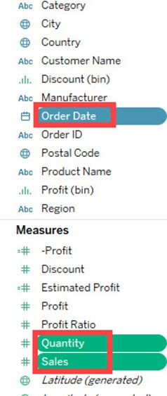

**Step 2)**

1. Click on 'Show Me' option present in the top right corner of Worksheet.
2. Select 'dual combination' icon as shown in the image.

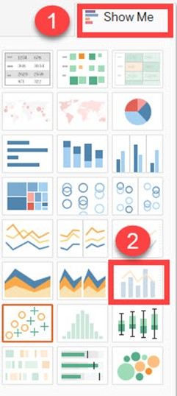

It creates a dual axis chart as shown in the figure.

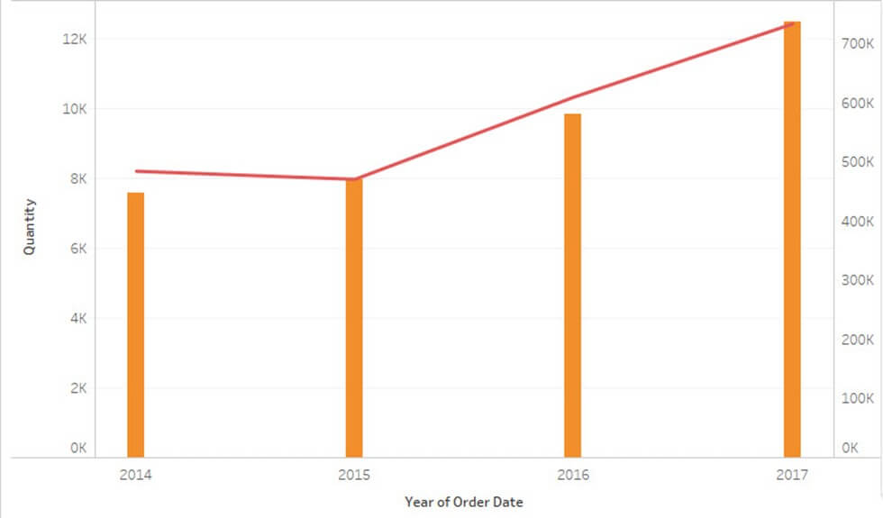

### Bubble Chart:

A bubble chart visualizes the measures and dimensions in the form of bubbles. The sizes of the bubbles determine the size of measure value for effective visualization. The color of bubbles can be set to differentiate the members present in a dimension. The procedure to create bubble chart is given below.

**Step 1)**Go to a new Worksheet.

1. Hold on the Control key in the keyboard.
2. Click on 'Sub-Category' and 'Sales'.

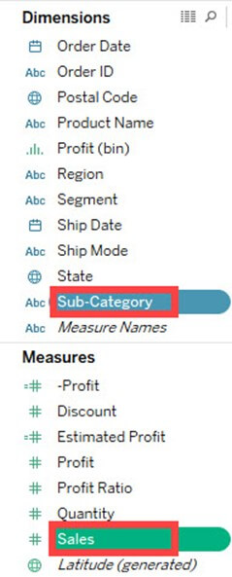**Step 2)**

1. Click on the 'Show Me' option present in the top right corner of the worksheet.
2. Select the 'Packed bubbles' icon as shown in the image.

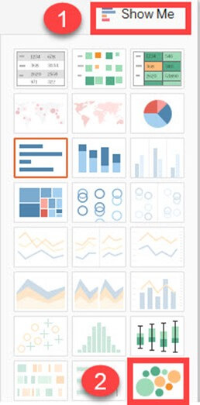

It creates a bubble chart as shown below

### https://www.guru99.com/images/tableau/060818_0650_TableauChar67.jpgHistogram:

A histogram can show the values present in a measure and its frequency. It shows the distribution of numerical data. As it shows both frequency and measure value by default, it can be useful in many cases. For example, if you want to analyze the discount given by a retail shop, you can visualize the amount of discount and its frequency using histogram. The procedure to create histogram is shown below.

**Step 1)** Go to a new Worksheet.

1. Select 'Discount' from the measures.

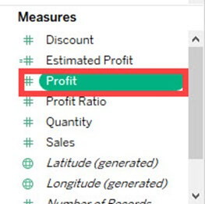

**Step 2)**

1. Click on 'Show Me' button present in the top right corner of the worksheet.
2. Select the 'Histogram' icon as shown in the image.

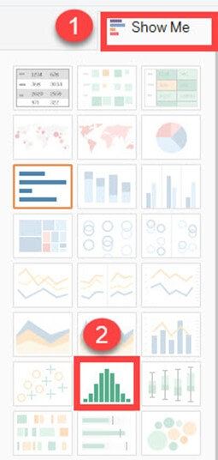

It creates a histogram chart in Tableau.

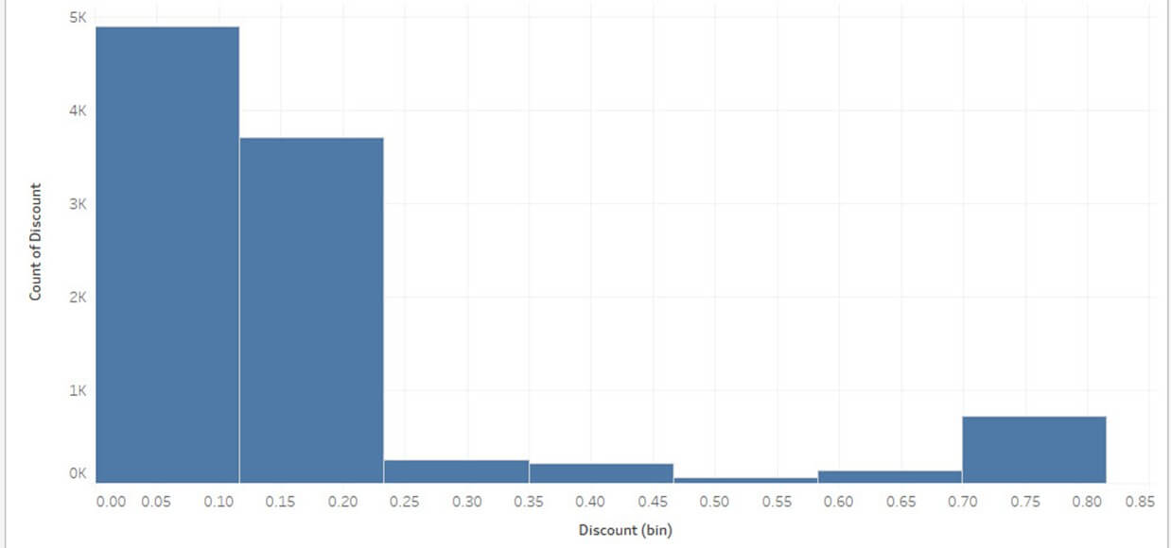

# 9.Best Tableau Alternatives & Competitors in 2019

Tableau is a data visualization tool that can connect to almost any data source. However, its licensing costs could be restrictive.

Here, is a curated list of top 10 tools that can replace Tableau. This list includes commercial as well as open source automation tools with popular features and latest download link.

### 1) Sisense:

[](https://www.sisense.com/)

[Sisense](https://www.sisense.com/) is a business intelligence tool which analyses and visualizes both big and disparate datasets, in real-time. It is an ideal tool for preparing complex data for creating dashboards with a wide variety of visualizations.

**Features:**

* Unify unrelated data into one centralized place
* Create a single version of truth with seamless data
* Allows to build interactive dashboards with no tech skills
* Query big data at very high speed
* Possible to access dashboards even in the mobile device
* Drag-and-drop user interface
* Eye-grabbing visualization
* Enables to deliver interactive terabyte-scale analytics
* Exports data to Excel, CSV, PDF Images and other formats
* Ad-hoc analysis of high-volume data
* Handles data at scale on a single commodity server
* Identifies critical metrics using filtering and calculations

**Download Link:** <https://www.sisense.com/get/watch-demo/>

### 2) Oracle:

[](https://www.oracle.com/database/data-warehouse/index.html)

[Oracle data warehouse](https://www.oracle.com/database/data-warehouse/index.html) software is a collection of data which is treated as a unit. The purpose of this database is to store and retrieve related information. It helps the server to reliably manage huge amounts of data so that multiple users can access the same data.

**Features:**

* Distributes data in the same way across disks to offer uniform performance
* Works for single-instance and real application clusters
* Offers real application testing
* Common architecture between any Private Cloud and Oracle's public cloud
* Hi-Speed Connection to move large data
* Works seamlessly with UNIX/Linux and Windows platforms
* It provides support for virtualization
* Allows connecting to the remote database, table, or view

**Download Link:**<https://www.oracle.com/downloads/index.html>

### 3) SAS:

[](https://www.sas.com/en_in/home.html)

[SAS](https://www.sas.com/en_in/home.html) is a leading Datawarehousing tool that allows accessing data across multiple sources. It can perform sophisticated analyses and deliver information across the organization.

**Features:**

* Activities managed from central locations. Hence, user can access applications remotely via the Internet
* Application delivery typically closer to a one-to-many model instead of one-to-one model
* Centralized feature updating, allows the users to download patches and upgrades.
* Allows viewing raw data files in external databases
* Manage data using tools for data entry, formatting, and conversion
* Display data using reports and statistical graphics

**Download Link:** <https://www.sas.com/en_in/home.html>

### 4) Pentaho

[](http://www.pentaho.com/)

[Pentaho](http://www.pentaho.com/) is a Data Warehousing and Business Analytics Platform. The tool has a simplified and interactive approach which empowers business users to access, discover and merge all types and sizes of data.

**Features:**

* Enterprise platform to accelerate the data pipeline
* Community Dashboard Editor allows the fast and efficient development and deployment
* Big data integration without a need for coding
* Simplified embedded analytics
* Visualize data with custom dashboards
* Ease of use with the power to integrate all data
* Operational reporting for mongo dB
* Platform to accelerate the data pipeline

**Download now:** <http://www.pentaho.com/testdrive>

### 5) QlikView:

[](http://www.qlik.com/us)

[Qlik](http://www.qlik.com/us) allows creating visualizations, dashboards, and apps. It also allows seeing the entire story that lives within data.

**Features:**

* Simple drag-and-drop interfaces to create flexible, interactive data visualizations
* Use natural search to navigate complex information
* Instantly respond to interactions and changes
* Supports multiple data sources and file types
* It allows easy security for data and content across all devices
* It shares relevant analyses, including apps and stories using centralized hub

**Download link:** [http://www.qlik.com](http://www.qlik.com/)

### 6) Dundas BI:

[https://www.guru99.com/images/2-2017/092917_0453_Top24Busine12.png](http://www.dundas.com/dundas-bi)

[Dundas](http://www.dundas.com/dundas-bi) is an enterprise-ready Business Intelligence platform. It is used for building and viewing interactive dashboards, reports, scorecards and more. It is possible to deploy Dundas BI as the central data portal for the organization or integrate it into an existing website as a custom BI solution.

**Features:**

* Easy access through web browser
* Allows to use sample or Excel data
* Server application with full product functionality
* Integrate and access all kind of data sources
* Ad hoc reporting tools
* Customizable data visualizations
* Smart drag and drop tools
* Visualize data through maps
* Predictive and advanced data analytics

**Download link:**<http://www.dundas.com/support/dundas-bi-free-trial>

### 7) BOARD:

[https://www.guru99.com/images/2-2017/092917_0453_Top24Busine6.png](http://www.board.com/en)

[Board](http://www.board.com/en) is a Management Intelligence Toolkit. It combines features of business intelligence and corporate performance management. It is designed to deliver business intelligence and business analytics in a single package.

**Features:**

* Analyse, simulate, plan and predict using a single platform
* To build customized analytical and planning applications
* Board All-In-One combines BI, Corporate Performance Management, and Business analytics
* It empowers businesses to develop and maintain sophisticated analytical and planning applications
* Proprietary platform helps to report by accessing multiple data sources

**Download link:** <http://www.board.com/en>

### 8) Profitbase BI:

[https://www.guru99.com/images/2-2017/092917_0453_Top24Busine17.png](http://www.profitbase.no/)

[Profitbase](http://www.profitbase.no/) is a business intelligence solution that delivers critical business information. It allows companies to monitor and manage their business performance. It is appropriate for many commercial markets, including manufacturing and retail.

**Features:**

* It helps make faster decisions based on continuously updated and accurate data
* It provides visibility into KPIs in finance, sales, AR/AP, as well as performance measures
* It is modular, scalable, and consists of a data warehouse augmented with OLAP cubes
* The BI software allows adding new business systems through acquisition or system upgrades
* It is a module based BI tool so that customers can select the analytic tools best suited for their requirements

**Download link:** <http://www.profitbase.no/?lang=en>

### 9) LongView:

[https://www.guru99.com/images/2-2017/092917_0453_Top24Busine22.png](http://www.longview.com/)

[LongView](http://www.longview.com/) Enterprise is a business intelligence reporting and analytics platform. It allows rapid creation of custom applications like reports, dashboards, etc.

**Features:**

* Delivers actionable, contextual knowledge to decision-makers at every level
* It analyzes information from multiple data sources such as ERP, OLAP, relational databases, and web services
* Single-sign-on if integrated with Windows or LDAP
* It is available on all web servers
* It allows exporting data and reports to Excel, PowerPoint, and PDF
* It allows users to share ad-hoc reports with other users
* Live data pulled from server and automatically refreshed in real time
* Automatic alerts based on thresholds
* Display data in animation and motion charts

**Download link:**<http://www.longview.com/>

### 10) Birst:

[https://www.guru99.com/images/2-2017/092917_0453_Top24Busine14.png](https://www.birst.com/)

[Birst](https://www.birst.com/) is a web-based networked BI and analytics solution. It connects insights from various teams and helps in making informed decisions. It allows decentralized users to augment the enterprise data model. It also offers a unified semantic layer to maintain definitions and key metrics.

**Features:**

* Enable Data as a Service
* Everyone is Cloud-Connected
* Helps end users to access and blend their data with IT-owned data
* Rapidly refine enterprise data
* Create trusted, governed user data
* Create corporate wide metrics
* Create top-down Virtual BI instances
* Blend corporate and local data
* It supports individual agility, transparently governed working with trusted corporate and departmental data

**Download link:** <https://www.birst.com/>

### 11) SAP BUSINESS INTELLIGENCE:

[](https://www.guru99.com/sap-bi.html)

[SAP BI](https://www.guru99.com/sap-bi.html) is an integrated business Intelligence software. It is an enterprise level application for open client/server systems. It has set new standards for providing the best business information management solutions.

**Features:**

* It provides highly flexible and most transparent business solutions
* The application developed using SAP can integrate with any system
* It follows modular concept for the easy setup and space utilization
* Allows to create next-generation database system that combines analytics and transactions
* Provide support for On-premise or cloud deployment
* Simplified data warehouse architecture
* Easy Integration with SAP and non-SAP applications

**Download Link:** <https://support.sap.com/en/my-support/software-downloads.html>

# 10. Tableau Tutorial for Beginners PDF

Tableau is a pioneering data visualization tool. Tableau connects to almost any data source like Datawarehouse, Excel, Database, etc. It provides real-time data insights in a matter of minutes. In this eBook, you will learn everything about Tableau.

## Key Highlights of Tableau Tutorial PDF are

* 188+ pages
* eBook Designed for beginners
* Beautifully annotated screenshots
* You will get lifetime access

### Inside this PDF

1. What is Tableau? Uses and Applications
2. Tableau Architecture & Server Components
3. How to Download & Install Tableau Public (Free) & Desktop (Trial)
4. Introduction to Tableau Desktop Software: Workspace & Navigation
5. Tableau Data Connections to Databases and Multiple Sources
6. Types of Filters in Tableau: Condition by Formula, Extract, Context
7. Tableau Create Group, Hierarchy, Sets & Sort Data
8. Tableau Charts & Graphs Tutorial: Types & Examples